1. Write any ten features of java.
Ans :
Here are 10 key features of Java that make it a powerful and widely used programming language:
1. Simple
- Java is easy to learn and use.
- Its syntax is clean and concise, and it removes complex features like pointers and operator overloading found in C/C++.
2. Object-Oriented
- Everything in Java is treated as an object (except primitive types).
- Concepts like inheritance, encapsulation, abstraction, and polymorphism are core to Java.
3. Platform Independent
- Java code is compiled into bytecode by the Java Compiler.
- This bytecode can run on any device that has the Java Virtual Machine (JVM) — making Java "write once, run anywhere".
4. Secure
- Java has built-in security features like:
  - Bytecode verification
  - Runtime security checks
  - No direct memory access
- Java applets run inside a sandbox to prevent unauthorized access.
5. Robust
- Java emphasizes early error checking and runtime exception handling.
- Features like garbage collection and strong memory management make it less prone to crashes.

6. Multithreaded
- Java supports multithreading (executing multiple threads concurrently).
- Useful for developing high-performance applications like games, web servers, etc.
7. Distributed
- Java has networking capabilities using APIs like java.net.
- It can be used to create distributed applications (e.g., using RMI and CORBA).
8. High Performance
- Although not as fast as C/C++, Java's performance is high due to:
  - Just-In-Time (JIT) compiler
  - Efficient memory management
  - Optimized runtime execution
9. Portable
- Java bytecode is platform-independent and can run on any system with a compatible JVM.
- It doesn’t depend on hardware-specific features.
10. Dynamic
- Java supports dynamic loading of classes.
- It allows programs to load classes at runtime, making it adaptable to evolving environments.

2. What is Unicode and Byte Code?
Ans :

Unicode:
Unicode is a universal character encoding standard that allows the representation of almost all characters from all writing systems (e.g., English, Chinese, Hindi, Arabic, emojis, etc.) used around the world.

In Java:
- Java uses Unicode to internally represent characters (data type char).
- Java's char data type is 16-bit, and it can store any Unicode character.
- This allows Java programs to be internationalized, i.e., support multiple languages and symbols.

Bytecode
Bytecode is an intermediate representation of your Java program. It is the compiled form of Java source code that can be executed by the Java Virtual Machine (JVM).

Key Points:
- When you compile a .java file using the Java compiler (javac), it generates a .class file that contains bytecode.
- Bytecode is platform-independent, which means the same .class file can run on any platform (Windows, Linux, Mac) that has a JVM.
- Bytecode is not human-readable but is machine-readable by the JVM.

3. How java is platform independent?
Ans :
Java achieves platform independence through the use of the Java Virtual Machine (JVM). Here's how the process works:

Compilation Process
- Write Java Code
You write your code in .java files.
- Compile Java Code
The Java Compiler (javac) compiles .java files into bytecode, which is stored in .class files.
  - Bytecode is not machine-specific, it’s a universal, intermediate code.
- Run with JVM
The bytecode is executed by the Java Virtual Machine (JVM).
The JVM translates bytecode into machine code for the underlying operating system.

4. What is JDK and JRE? Differentiate?
Ans :

JDK (Java Development Kit)
- Definition: A software development kit used to develop Java applications.
- Includes:
  - JRE (Java Runtime Environment)
  - Java Compiler (javac)
  - Debuggers, documentation tools (javadoc), and other development tools
- Use: Required when you want to write, compile, and debug Java programs.

🔹 JRE (Java Runtime Environment)
- Definition: A software package that provides the environment to run Java programs.
- Includes:
  - JVM (Java Virtual Machine)
  - Core Java libraries
  - Supporting files for execution
- Use: Required only to run Java applications. You cannot develop Java programs with just the JRE.

Feature | JDK (Java Development Kit) | JRE (Java Runtime Environment)
Purpose | To develop and run Java programs | To run Java programs only
Includes | JRE + development tools (e.g. compiler) | JVM + core libraries
Contains JVM? | Yes | Yes
Compiler (javac) | Included | Not Included
Development tools | Included | Not Included
Used by | Java developers | End users who run Java apps
5. What is the task of Class Loader, Verifier, JIT Compiler in JRE.
Ans :

1. Class Loader
Task: Loads Java .class files (bytecode) into memory for execution by the JVM.

Responsibilities:
- Loads classes dynamically at runtime (only when needed).
- Divides loading responsibility into three class loaders:
  - Bootstrap ClassLoader – loads core Java classes (java.lang, java.util etc.)
  - Extension ClassLoader – loads classes from ext directory.
  - Application ClassLoader – loads classes from your application's classpath.
- Ensures that each class is loaded only once into the JVM.
- Supports dynamic loading: classes can be loaded from various sources (disk, network, etc.).

2. Bytecode Verifier (Verifier)
Task: Checks the loaded bytecode for security and integrity before it is executed.

Responsibilities:
- Ensures the bytecode:
  - Follows Java language rules.
  - Does not perform illegal memory access.
  - Does not corrupt the JVM.
- Prevents:
  - Stack overflows/underflows.
  - Access to private/protected data.
  - Code that violates access rights or performs dangerous operations.
- Guarantees the code is safe to execute.
Acts as a security gatekeeper before the code runs.

🔹 3. JIT Compiler (Just-In-Time Compiler)
Task: Compiles bytecode into native machine code at runtime for better performance.

Responsibilities:
- Converts frequently-used bytecode into native code for faster execution.
- Uses runtime optimizations:
  - Method inlining
  - Loop unrolling
  - Dead code elimination
- Works alongside the interpreter, but gradually takes over execution of hot (frequently run) code.
- Improves speed by avoiding repeated interpretation of the same bytecode.
Translates “hot spots” of code into optimized machine instructions.

6. Write/compile/execute Hello World program in Java
Ans :
public class C6_hello {
public static void main(String[] args) {
Name.info(); //method to print name and enrollment number.
System.out.print("hello, world!");
}
}

#output
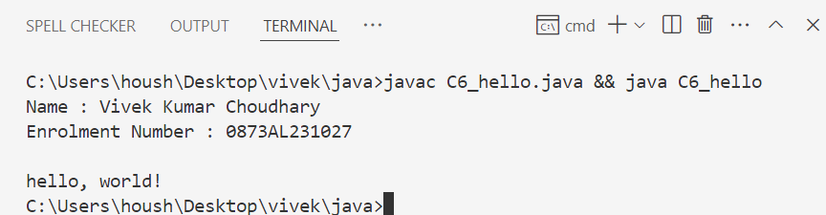

7. Program to find area and circumference of circle
Ans :
import java.util.Scanner;
public class C7_area {
public static void main(String[] args){
Name.info(); //method to print name and enrollment number.
double radius,area,circumference;
Scanner scr = new Scanner(System.in);
System.out.print("enter radius of circle : ");
radius = scr.nextFloat();
circumference = 2*3.14*radius;
area = 3.14*radius*radius;
System.out.println("area of circle : " +area);
System.out.println("circumference of circle : " +circumference);

}
}

#output

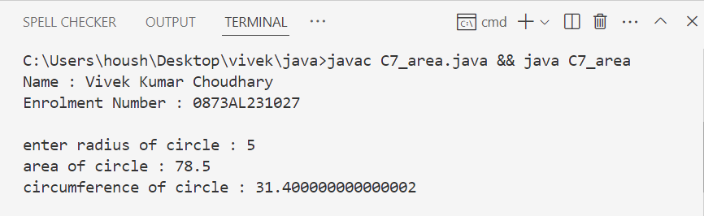

8. Program to calculate sum of 5 subjects &amp; find percentage.
Ans :
import java.util.Scanner;
public class C8_percentage {
public static void main(String[] args) {
Scanner scr = new Scanner(System.in);
Name.info(); //method to print name and enrollment number.

double sub1,sub2,sub3,sub4,sub5,result;
System.out.print("enter marks of subject 1 : ");
sub1 = scr.nextFloat();

System.out.print("enter marks of subject 2 : ");
sub2 = scr.nextFloat();

System.out.print("enter marks of subject 3 : ");
sub3 = scr.nextFloat();

System.out.print("enter marks of subject 4 : ");
sub4 = scr.nextFloat();

System.out.print("enter marks of subject 5 : ");
sub5 = scr.nextFloat();

result = (sub1+sub2+sub3+sub4+sub5)/5;
System.out.println("you got " +result+ " %");
}
}

#output

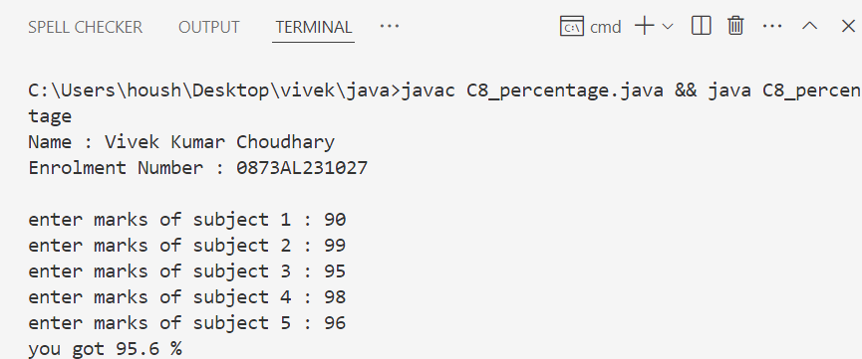

9. Write a program to calculate simple interest.
Ans :
import java.util.Scanner;
public class C9_smp_Interest {
public static void main(String[] args) {
Scanner scr = new Scanner(System.in);
Name.info(); //method to print name and enrollment number.
float P ,R,T ,SI;
System.out.print("enter principle amount : ");
P = scr.nextFloat();
System.out.print("enter rate of interest : ");
R = scr.nextFloat();
System.out.print("enter time in year : ");
T = scr.nextFloat();

SI = (P*R*T)/100;
System.out.println("simple interest is "+SI);

}
}

#output

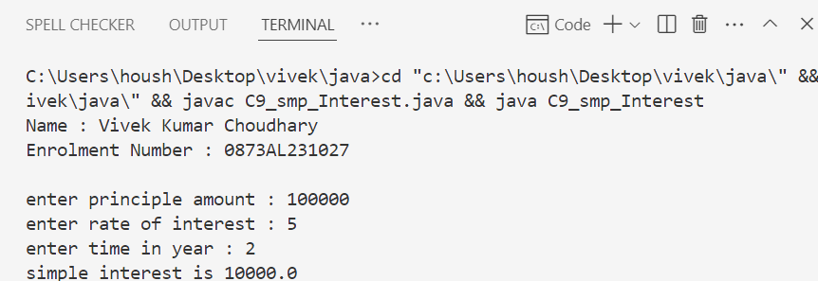

10. Write a program which accepts days(eg. 670 days) as integer and display total number of years, months and days in it.
Ans :
//days to year, months and days
import java.util.Scanner;
public class C10_days {
public static void main(String[] args) {
Name.info(); //method to print name and enrollment number.
Scanner scr = new Scanner(System.in);
int days,years,days_left,month;
System.out.print("enter number of days: ");
days = scr.nextInt();
years = days/365;
days_left = days%365;
month = days_left/30;
days = days_left%30;
System.out.printf(" %d years %d months and %d days",years,month,days);
}
}

#output

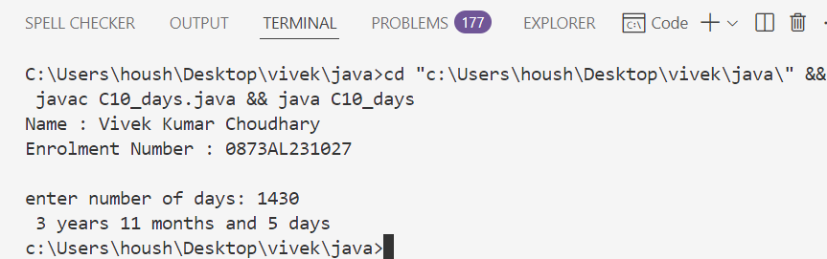

11. Program to convert temperature from Fahrenheit to Celsius as C= 5*(f-32)/9
Ans :
//convert temperature from Fahrenheit to celsius
import java.util.Scanner;
public class C11_temperature {
public static void main(String[] args) {
Scanner scr = new Scanner(System.in);
Name.info(); //method to print name and enrollment number.
float Fahrenheit;
System.out.print("Enter temperature in Fahrenheit : ");
Fahrenheit = scr.nextFloat();
System.out.println("temperature in celsius is : " + (5*(Fahrenheit-32)/9));
}
}

#output

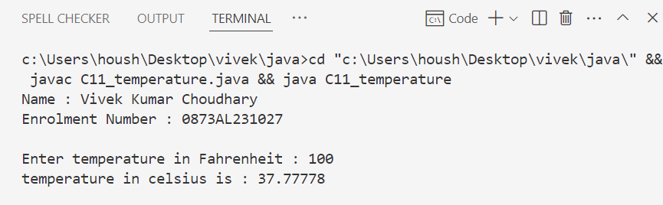

12. Program to swap two no’s without using third variable.
Ans :
import java.util.Scanner;

public class C12_swap {
public static void main(String[] args){
Scanner scr = new Scanner(System.in);
Name n = new Name();
Name.info(); //method to print name and enrollment number.
int num1,num2;
System.out.print("Enter num1 : ");
num1 = scr.nextInt();
System.out.print("Enter num2 : ");
num2 = scr.nextInt();

num1 = num1+num2;
num2 = num1-num2;
num1 = num1-num2;
System.out.printf("num1 = %d \nnum2 = %d",num1,num2);
}
}

#output

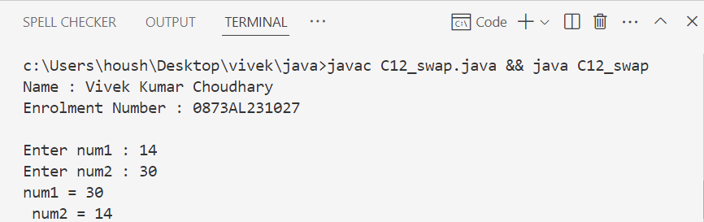

13. Find the result of following (accept values for variables used in right side of
expression)
a. y=x 2 +3x-7 (print value of Z)
b. y=x++ + ++x (print value of x and y)
c. z= x++ - --y - --x + x++ (print value of x ,y and z)
d. z = x &amp;&amp; y || !(x||y) (print value of Z)
Ans :
import java.util.Scanner;

public class ExpressionEvaluation {
public static void main(String[] args) {
Name.info(); // Print name and enrollment number

Scanner scanner = new Scanner(System.in);

// For (a), (b), (c) assume x and y are integers
// For (d), assume x and y are booleans

// a. y = x^2 + 3x - 7
System.out.print("Enter integer value for x (for a): ");
int x_a = scanner.nextInt();
int y_a = x_a * x_a + 3 * x_a - 7;
System.out.println("a) Value of y = " + y_a);

// b. y = x++ + ++x
System.out.print("\nEnter integer value for x (for b): ");
int x_b = scanner.nextInt();
int y_b = x_b++ + ++x_b;
System.out.println("b) After evaluation:");
System.out.println(" x = " + x_b);
System.out.println(" y = " + y_b);

// c. z = x++ - --y - --x + x++
System.out.print("\nEnter integer value for x (for c): ");
int x_c = scanner.nextInt();
System.out.print("Enter integer value for y (for c): ");
int y_c = scanner.nextInt();
int z_c = x_c++ - --y_c - --x_c + x_c++;
System.out.println("c) After evaluation:");
System.out.println(" x = " + x_c);
System.out.println(" y = " + y_c);
System.out.println(" z = " + z_c);

// d. z = x && y || !(x || y)
// Here x and y are boolean variables
System.out.print("\nEnter boolean value for x (true/false) (for d): ");
boolean x_d = scanner.nextBoolean();
System.out.print("Enter boolean value for y (true/false) (for d): ");
boolean y_d = scanner.nextBoolean();
boolean z_d = (x_d && y_d) || !(x_d || y_d);
System.out.println("d) Value of z = " + z_d);

scanner.close();
}
}

#output

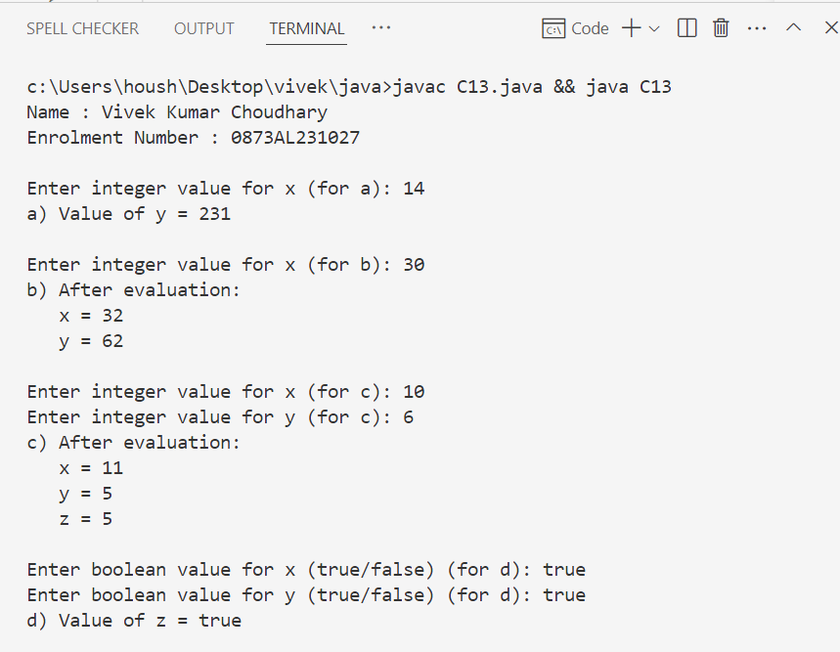

14. Program to reverse a given number.
Ans :
import java.util.Scanner;
public class C14_reverse
{
public static void main(String args[]){
Scanner sc = new Scanner(System.in);
Name.info(); //method to print name and enrollment number.
int n,t,rv=0;
System.out.print("enter number to reverse: ");
n = sc.nextInt();
while (n!=0){
t = n%10;
rv = (rv*10)+t;
n = n/10;
}
System.out.println("reverse value : " +rv);
}
}

#output

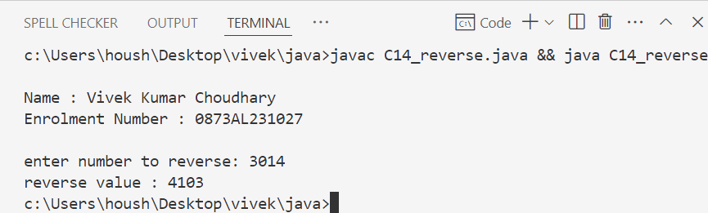

15. In a company an employee is paid as under:
If his basic salary is less than Rs. 1500, then HRA = 10% of basic salary and DA = 90% of basic salary.
If his salary is either equal to or above Rs. 1500, then HRA = Rs. 500 and DA = 98% of basic salary.
If the employees salary is input by the user write a program to find his gross salary. GS=Basic+DA+HRA
Ans :
import java.util.Scanner;
public class C15_salary {
public static void main(String[] args) {
float salary,gross_salary,DA,HRA,Basic;
Scanner scr = new Scanner(System.in);
Name.info(); //method to print name and enrollment number.
System.out.print("what's your salary : ");
salary = scr.nextFloat();
if (salary > 0 && salary < 1500){
Basic = salary;
DA = (90*salary)/100;
HRA = (10*salary)/100;
gross_salary = Basic + DA + HRA;
System.out.println("your gross salary is : "+gross_salary);
}else if(salary >= 1500){
Basic = salary;
DA = (98*salary)/100;
HRA = 500;
gross_salary = Basic + DA + HRA;
System.out.println("your gross salary is : "+gross_salary);
}else{
System.out.println("wrong input");}}}

#output

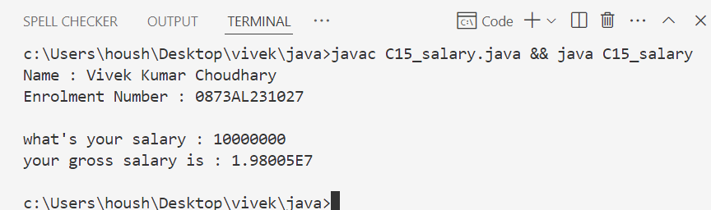

16. Program to find greatest in 3 numbers.
Ans :
import java.util.Scanner;
public class C16_biggest {
public static void main(String[] args) {
Scanner scr = new Scanner(System.in);
Name.info(); //method to print name and enrollment number.
int num1,num2,num3,d;
System.out.print("Enter number 1 : ");
num1 = scr.nextInt();
System.out.print("Enter number 2 : ");
num2 = scr.nextInt();
System.out.print("Enter number 3 : ");
num3 = scr.nextInt();
d = (num1>num2 && num1 > num3)?num1:(num2>num3)?num2:num3;
System.out.println("greatest number is " +d);

}

}

#output

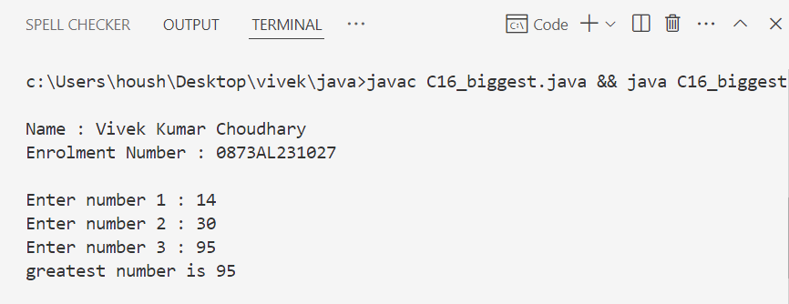

17. Program to check that entered year is leap year or not.
Ans :
import java.util.Scanner;
public class C17_leap {
public static void main(String[] args){
Scanner scr = new Scanner(System.in);
Name.info(); //method to print name and enrollment number.
int year;
System.out.print("enter year to check leap or not : ");
year = scr.nextInt();
if ((year % 400 == 0) || (year%4 == 0 && year%100 !=0)){
System.out.println("leap year");
}else{
System.out.println("not a leap year");
}
}
}

#output

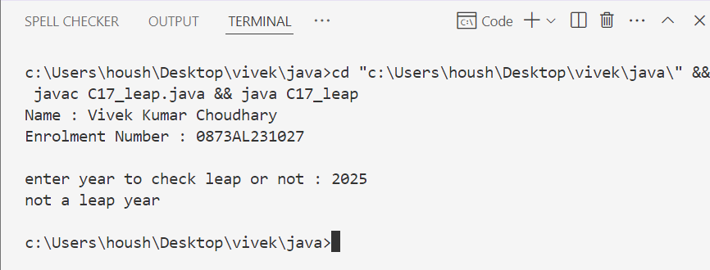

18. Accept person age(int), gender(int 1 for male and 0 for female), then check whether person is eligible for marriage or not.
Ans :
import java.util.Scanner;
public class Assi18 {
public static void main(String[] args) {
Scanner scr = new Scanner(System.in);
Name.info(); //method to print name and enrollment number.
int age,gender;
System.out.print("enter your age : ");
age = scr.nextInt();
System.out.print("your gender(1 for male & 0 for female) : ");
gender = scr.nextInt();
if (gender == 0){
if (age > 18){
System.out.println("eligible for marriage.");
}else{
System.out.println("not eligible for marriage.");
}
}else if (gender == 1){
if (age > 21){
System.out.println("eligible for marriage.");
}else{
System.out.println("not eligible for marriage.");
}
}else{
System.out.println("invalid inputs.");
}}}

#output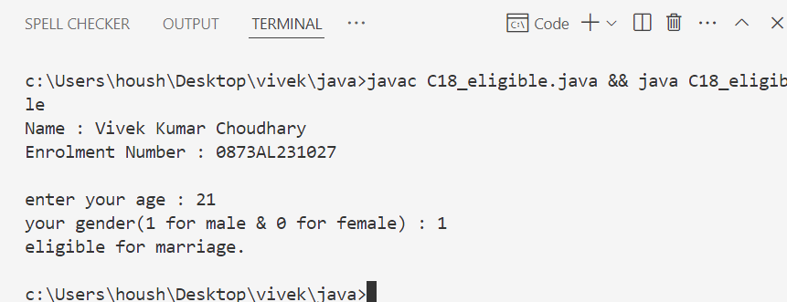
19. Program to print a table of any number.
Ans:
import java.util.Scanner;

public class C19_table {
public static void main(String[] args){
Scanner sc = new Scanner(System.in);
Name.info(); //method to print name and enrollment number.
int num;
System.out.print("Enter number to print table : ");
num = sc.nextInt();
for(int i = 1;i<=10;i++){
int result = i*num;
System.out.printf("%d X %d = %d\n",num,i,result);
}
}
}

#output

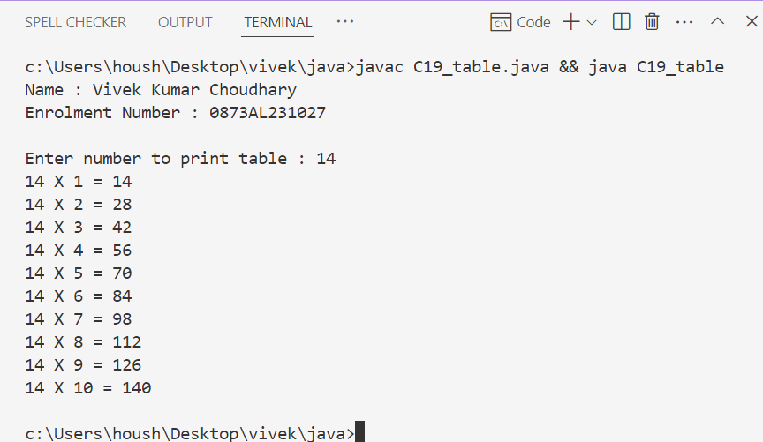

20. Program to check whether number is prime or not
Ans :
import java.util.Scanner;

public class C20_prime {
public static void main(String[] args) {
Scanner scanner = new Scanner(System.in);
Name.info(); //method to print name and enrollment number.
System.out.print("Enter a number: ");
int num = scanner.nextInt();
boolean isPrime = true;
// 0 and 1 are not prime numbers
if (num <= 1) {
isPrime = false;
} else {
// Check from 2 to sqrt(num)
for (int i = 2; i <= Math.sqrt(num); i++) {
if (num % i == 0) {
isPrime = false;
break;
}
}
}
if (isPrime) {
System.out.println(num + " is a Prime Number.");
} else {
System.out.println(num + " is Not a Prime Number.");
}
scanner.close();
}
}

#output

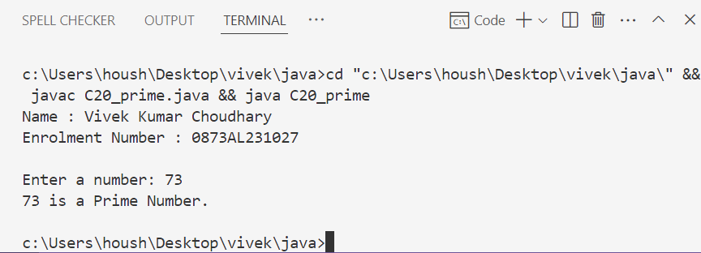

21. Calculate series : 1² +2² +3² +4² +.........+n²
Ans :
import java.util.Scanner;
import java.math.*;
public class Assi22 {
public static void main(String[] args) {
Scanner sc = new Scanner(System.in);
Name.info(); //method to print name and enrollment number.
int num, result = 0;
System.out.print("enter number : ");
num = sc.nextInt();
for(int i = 1;i<=num;i++){
result += Math.pow(i, 2);
}

System.out.printf("sum of series upto %d elements is "+result,num);
}
}

#output

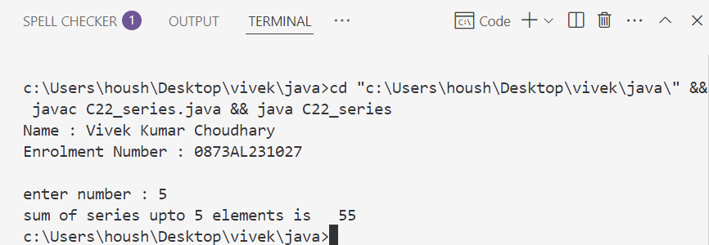

22. Calculate sum of Lucas series (up to 10 terms) :
1, 2, 3, 6, 11, 20 ,........
Ans :
public class C23 {
public static void main(String[] args) {
Name.info(); // Print name and enrollment number

int n = 10; // Number of terms
int[] series = new int[n];

// Initialize first three terms
series[0] = 1;
series[1] = 2;
series[2] = 3;
int sum = series[0] + series[1] + series[2];

// Calculate next terms using series[n] = series[n-1] + series[n-2] + series[n-3]
for (int i = 3; i < n; i++) {
series[i] = series[i - 1] + series[i - 2] + series[i - 3];
sum += series[i];
}

// Print the series
System.out.print("Series terms: ");
for (int i = 0; i < n; i++) {
System.out.print(series[i] + " ");
}
System.out.println("\nSum of first " + n + " terms = " + sum);
}
}

#output

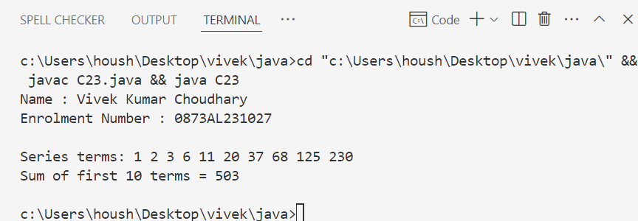
23. Print all prime numbers between two given numbers.
Ans :
import java.util.Scanner;
public class C24_prime {
// Function to check if a number is prime
public static boolean isPrime(int num) {
if (num <= 1) return false;
for (int i = 2; i <= Math.sqrt(num); i++) {
if (num % i == 0)
return false;
}
return true;
}
public static void main(String[] args) {
Scanner scanner = new Scanner(System.in);
Name.info(); //method to print name and enrollment number.
// Input range from user
System.out.print("Enter the starting number: ");
int start = scanner.nextInt();
System.out.print("Enter the ending number: ");
int end = scanner.nextInt();
System.out.println("Prime numbers between " + start + " and " + end + " are:");
// Loop through the range and print primes
for (int i = start; i <= end; i++) {
if (isPrime(i)) {
System.out.print(i + " ");
}
}
scanner.close();
}
}

#output

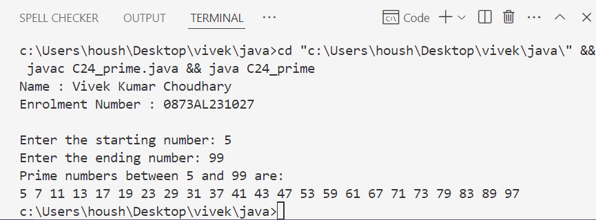
24. Program to show sum and average of 10 element array. Accept array elements from user.
Ans :
import java.util.Scanner;
public class Assi25 {
public static void main(String[] args) {
Name.info(); //method to print name and enrollment number.
int a[] = new int[10];
Scanner sc = new Scanner(System.in);
int num, i, len=10;
float avg = 0, sum = 0;
for (i = 0;i < 10;i++){
System.out.printf("Enter element %d : ",i+1);
num = sc.nextInt();
a[i] = num;
}
len = a.length;
for (i = 0;i < 10 ; i++){
sum += a[i];
}
System.out.println("sum = "+sum);
System.out.println("average = "+sum/len);
}
}
#output

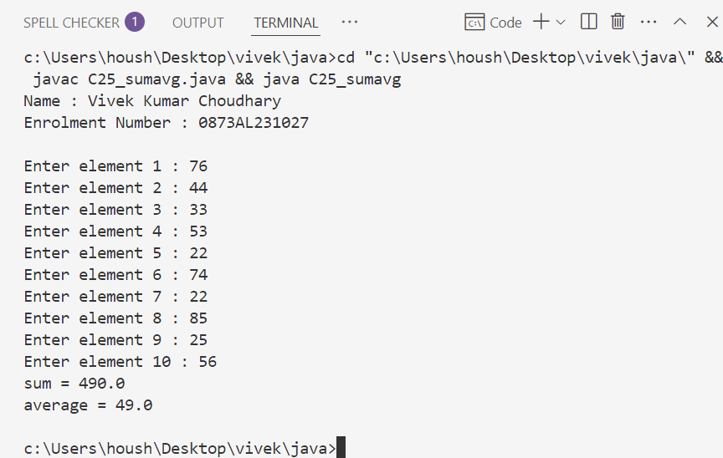
25. Sort ten element array in descending order.
Ans :
import java.util.Scanner;
import java.util.Arrays;
public class C26 {
public static void main(String[] args) {
Name.info(); // Print name and enrollment number
Scanner scanner = new Scanner(System.in);
int[] arr = new int[10];// Input 10 elements
System.out.println("Enter 10 elements:");
for (int i = 0; i < 10; i++) {
System.out.print("Element " + (i + 1) + ": ");
arr[i] = scanner.nextInt();
}// Sort in descending order using simple bubble sort
for (int i = 0; i < arr.length - 1; i++) {
for (int j = 0; j < arr.length - i - 1; j++) {
if (arr[j] < arr[j + 1]) { // Swap arr[j] and arr[j + 1]
int temp = arr[j];
arr[j] = arr[j + 1];
arr[j + 1] = temp;}}}// Output the sorted array
System.out.println("Array in Descending Order:");
for (int num : arr) {
System.out.print(num + " ");}
scanner.close();}}
#output

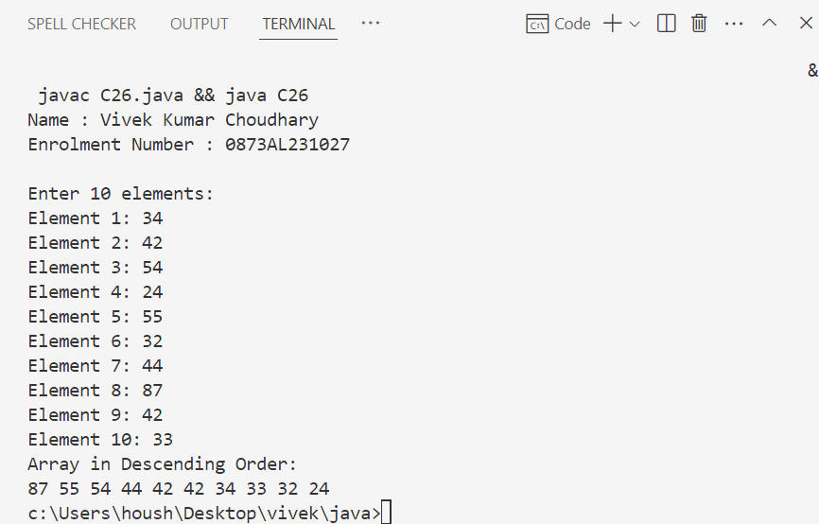
26. Create a array of 17 elements in 5 rows. And calculate sum of all elements.
Ans:
import java.util.Scanner;

public class C27 {
public static void main(String[] args) {
Name.info(); // Print name and enrollment number

Scanner scanner = new Scanner(System.in);

int rows = 5;
int cols = 4; // We'll use 4 columns per row, but last row will have only 1 element (5*4=20 > 17)
int[][] arr = new int[rows][cols];
int count = 0, totalElements = 17, sum = 0;

System.out.println("Enter 17 elements:");

for (int i = 0; i < rows && count < totalElements; i++) {
for (int j = 0; j < cols && count < totalElements; j++) {
System.out.print("Enter element " + (count + 1) + ": ");
arr[i][j] = scanner.nextInt();
sum += arr[i][j];
count++;
}
}

// Display array in matrix format
System.out.println("\nArray elements in 5-row layout:");
count = 0;
for (int i = 0; i < rows; i++) {
for (int j = 0; j < cols; j++) {
if (count < totalElements) {
System.out.print(arr[i][j] + "\t");
count++;
}
}
System.out.println();
}

// Output total sum
System.out.println("\nSum of all 17 elements: " + sum);

scanner.close();
}
}

#output

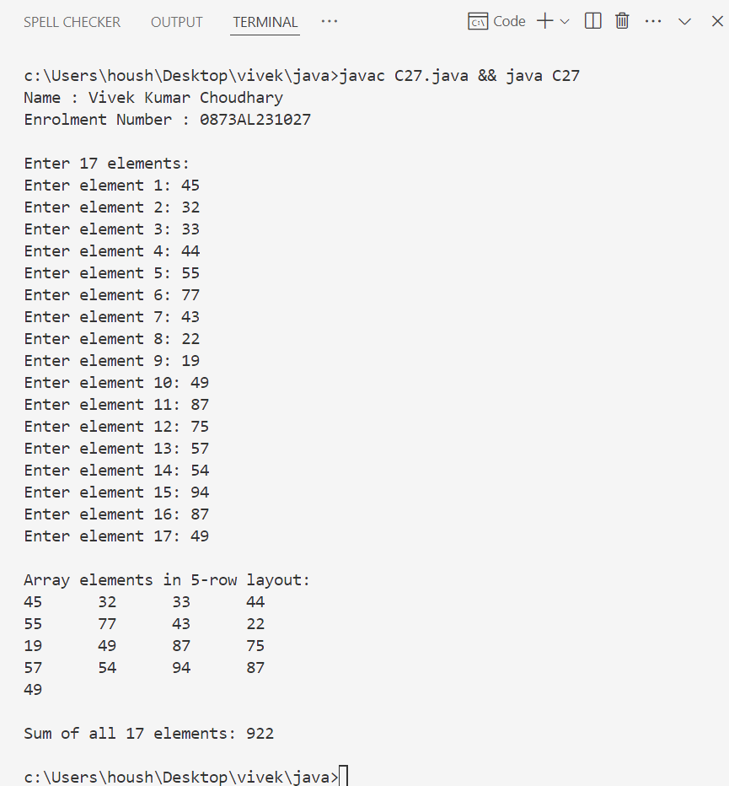

27. Program to find multiplication of two 3X3 matrices.
Ans :
import java.util.Scanner;

public class C28 {
public static void main(String[] args) {
Name.info(); // Print name and enrollment number

Scanner scanner = new Scanner(System.in);

int[][] A = new int[3][3]; // First matrix
int[][] B = new int[3][3]; // Second matrix
int[][] result = new int[3][3]; // Resultant matrix

// Input for first matrix
System.out.println("Enter elements of first 3x3 matrix (A):");
for (int i = 0; i < 3; i++) {
for (int j = 0; j < 3; j++) {
System.out.print("A[" + i + "][" + j + "] = ");
A[i][j] = scanner.nextInt();
}
}

// Input for second matrix
System.out.println("\nEnter elements of second 3x3 matrix (B):");
for (int i = 0; i < 3; i++) {
for (int j = 0; j < 3; j++) {
System.out.print("B[" + i + "][" + j + "] = ");
B[i][j] = scanner.nextInt();
}
}

// Matrix multiplication logic
for (int i = 0; i < 3; i++) { // Rows of A
for (int j = 0; j < 3; j++) { // Columns of B
result[i][j] = 0;
for (int k = 0; k < 3; k++) { // Columns of A / Rows of B
result[i][j] += A[i][k] * B[k][j];
}
}
}

// Display Resultant Matrix
System.out.println("\nResultant Matrix (A × B):");
for (int i = 0; i < 3; i++) {
for (int j = 0; j < 3; j++) {
System.out.print(result[i][j] + "\t");
}
System.out.println();
}

scanner.close();
}
}

#output

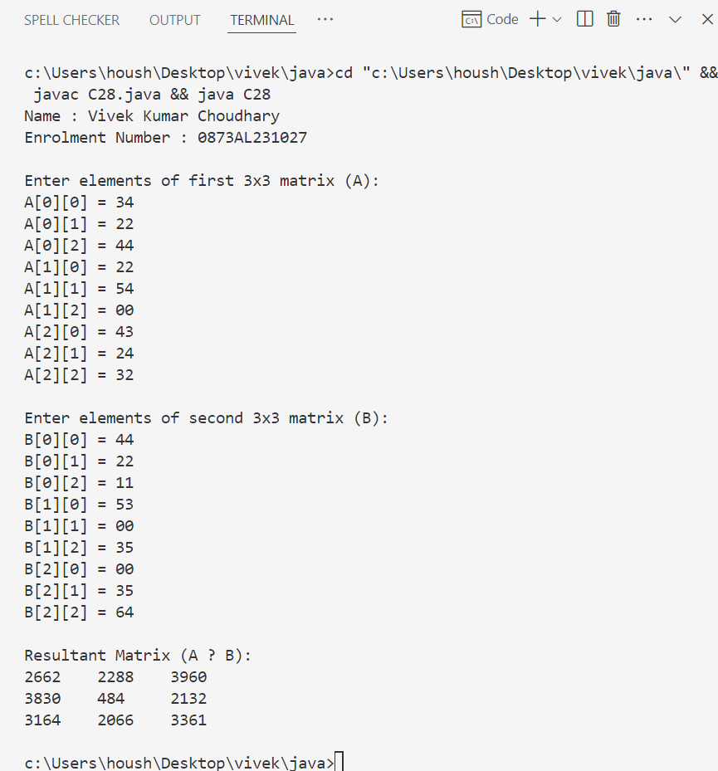

28. Program to print transpose of a matrix.
Ans :
import java.util.Scanner;

public class C29 {
public static void main(String[] args) {
Name.info(); // Print name and enrollment number

Scanner scanner = new Scanner(System.in);

// Get dimensions of matrix
System.out.print("Enter number of rows: ");
int rows = scanner.nextInt();

System.out.print("Enter number of columns: ");
int cols = scanner.nextInt();

int[][] matrix = new int[rows][cols];
int[][] transpose = new int[cols][rows];

// Input matrix elements
System.out.println("Enter elements of the matrix:");
for (int i = 0; i < rows; i++) {
for (int j = 0; j < cols; j++) {
System.out.print("matrix[" + i + "][" + j + "] = ");
matrix[i][j] = scanner.nextInt();
}
}

// Transpose logic
for (int i = 0; i < rows; i++) {
for (int j = 0; j < cols; j++) {
transpose[j][i] = matrix[i][j];
}
}

// Display original matrix
System.out.println("\nOriginal Matrix:");
for (int i = 0; i < rows; i++) {
for (int j = 0; j < cols; j++) {
System.out.print(matrix[i][j] + "\t");
}
System.out.println();
}

// Display transposed matrix
System.out.println("\nTranspose of Matrix:");
for (int i = 0; i < cols; i++) {
for (int j = 0; j < rows; j++) {
System.out.print(transpose[i][j] + "\t");
}
System.out.println();
}

scanner.close();
}
}

#output

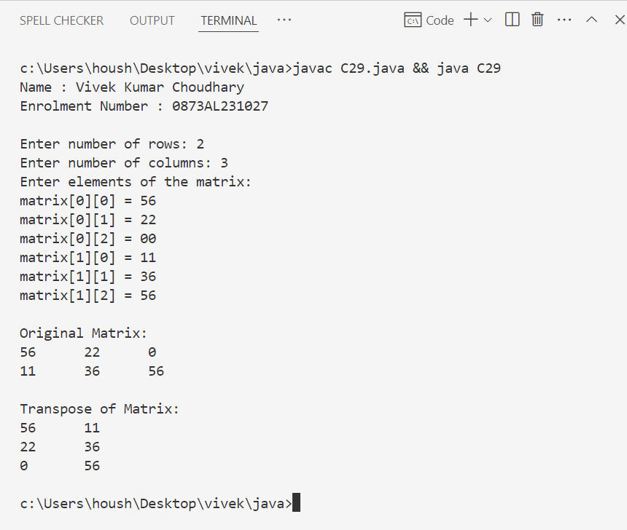

29. Create a class to calculate Area of circle with one data member to store the radius and another to store area value.
Create method members
1. init - to input radius from user
2. calc - to calculate area
3. display- to display area
Ans :
import java.util.Scanner;

public class C30 {
double radius; // Data member to store radius
double area; // Data member to store area

// Method to input radius
void init() {
Scanner scanner = new Scanner(System.in);
System.out.print("Enter radius of the circle: ");
radius = scanner.nextDouble();
scanner.close();
}

// Method to calculate area
void calc() {
area = Math.PI * radius * radius;
}

// Method to display area
void display() {
System.out.println("Radius: " + radius);
System.out.println("Area of the circle: " + area);
}

// Main method
public static void main(String[] args) {
Name.info(); // Print name and enrollment number

C30 circle = new C30();
circle.init(); // Input radius
circle.calc(); // Calculate area
circle.display(); // Display result
}
}

#output

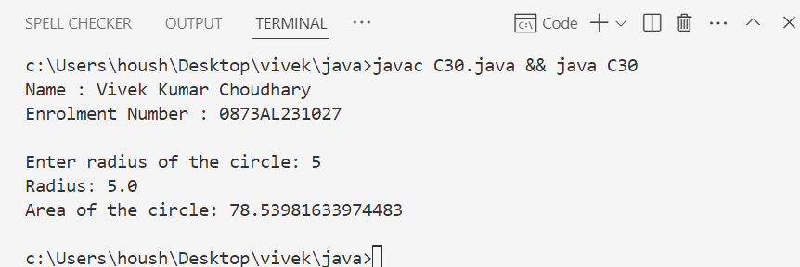

30. Create a class MathOperation with two data member X and Y to store the operand and third data member R to store result of operation.
Create method members
● init - to input X and Y from user
● add - to add X and Y and store in R
● multiply - to multiply X and Y and store in R
● power - to calculate X Y and store in R
● display- to display Result R
Ans :
import java.util.Scanner;

public class C31{
double X, Y; // operands
double R; // result

// Method to input X and Y
void init() {
Scanner scanner = new Scanner(System.in);
System.out.print("Enter value for X: ");
X = scanner.nextDouble();

System.out.print("Enter value for Y: ");
Y = scanner.nextDouble();
scanner.close();
}

// Method to add X and Y
void add() {
R = X + Y;
}

// Method to multiply X and Y
void multiply() {
R = X * Y;
}

// Method to calculate X^Y
void power() {
R = Math.pow(X, Y);
}

// Method to display result
void display() {
System.out.println("Result (R): " + R);
}

// Main method
public static void main(String[] args) {
Name.info(); // Print name and enrollment number

C31 op = new C31();

op.init(); // Take input
op.add(); // Perform addition
System.out.print("Addition: ");
op.display(); // Display result

op.multiply(); // Perform multiplication
System.out.print("Multiplication: ");
op.display(); // Display result

op.power(); // Perform power
System.out.print("Power (X^Y): ");
op.display(); // Display result
}
}

#output

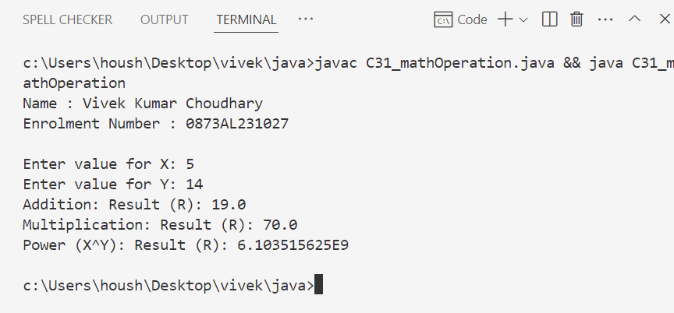

31. Create a class MathOperation containing method ‘multiply’ to calculate multiplication
of following arguments.
a. two integers
b. three float
c. all elements of array
d. one double and one integer
Ans :
public class C32_mathOperation{

// a. Multiply two integers
void multiply(int a, int b) {
int result = a * b;
System.out.println("Multiplication of two integers: " + result);
}

// b. Multiply three floats
void multiply(float a, float b, float c) {
float result = a * b * c;
System.out.println("Multiplication of three floats: " + result);
}

// c. Multiply all elements of an integer array
void multiply(int[] arr) {
int result = 1;
for (int num : arr) {
result *= num;
}
System.out.println("Multiplication of array elements: " + result);
}

// d. Multiply one double and one integer
void multiply(double a, int b) {
double result = a * b;
System.out.println("Multiplication of double and integer: " + result);
}

public static void main(String[] args) {
Name.info(); // Print name and enrollment number

C32_mathOperation mo = new C32_mathOperation();

// Testing all versions of multiply
mo.multiply(4, 5); // two integers
mo.multiply(1.2f, 3.5f, 2.0f); // three floats
mo.multiply(new int[]{2, 3, 4}); // array elements
mo.multiply(3.5, 4); // double and integer
}
}

#output

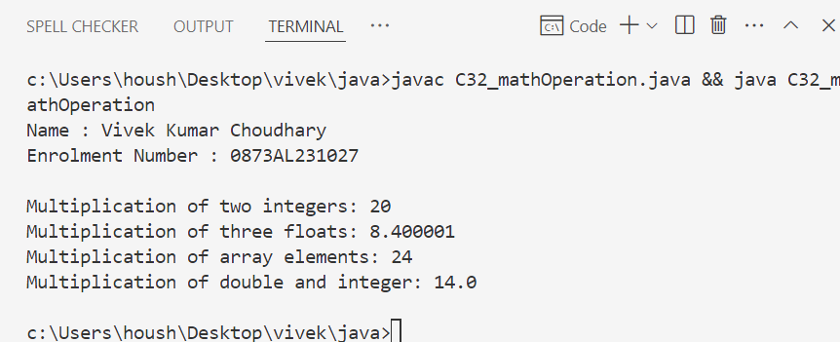

32. What are the two types of Exceptions in Java? What are the differences between them?
Ans :

Types of Exceptions in Java

🔹 1. Checked Exceptions (Compile-Time Exceptions)
- Checked at compile-time by the compiler.
- Must be handled using try-catch or declared using throws.
- Typically caused by external issues (like missing files, database errors).
- Programs will not compile if not handled properly.
- All checked exceptions are subclasses of Exception (excluding RuntimeException).

🔸 Examples:
- IOException
- FileNotFoundException
- SQLException
- ParseException

🔹 2. Unchecked Exceptions (Runtime Exceptions)
- Checked at runtime, not at compile-time.
- Handling them is optional.
- Usually caused by programming errors (like null references, divide by zero).
- Program will compile but may throw exceptions during execution.
- All unchecked exceptions are subclasses of RuntimeException.

🔸 Examples:
- NullPointerException
- ArithmeticException
- ArrayIndexOutOfBoundsException
- IllegalArgumentException

Feature | Checked Exception | Unchecked Exception
Checked by compiler | Yes | No
Occurs at | Compile-time | Runtime
Handling required? | Yes (mandatory) | No (optional)
Caused by | External issues (files, DB, network, etc.) | Programming mistakes (logic errors)
Subclass of | Exception (excluding RuntimeException) | RuntimeException
Examples | IOException, SQLException | NullPointerException, ArithmeticException

33. What are the Memory Allocations available in Java?
Ans :

Memory Allocations in Java
Java provides several types of memory areas where different types of data and objects are stored during the execution of a program.

🔹 1. Heap Memory
- Stores: Objects and class instances.
- Managed by: Garbage Collector.
- Accessible from: All parts of the application.
- Grows as needed (up to max heap size).
Example: When you use new to create an object, it goes to the heap.
Student s = new Student(); // Stored in heap memory

🔹 2. Stack Memory
- Stores: Method-local variables and function calls.
- Each thread has its own stack.
- Fast access and memory is automatically deallocated once method exits.
- No Garbage Collection needed.
Example: Primitive types or object references inside methods.
int x = 5; // Stored in stack memory

🔹 3. Method Area (or Metaspace in Java 8+)
- Stores: Class metadata, method data, static variables, constants.
- Shared across all threads.
- In Java 8 and later, Metaspace replaces the PermGen space.

🔹 4. Program Counter (PC) Register
- Each thread has its own PC Register.
- Stores the address of the current instruction being executed.
- Helps the JVM track execution flow per thread.

🔹 5. Native Method Stack
- Used for: Native method execution (non-Java code).
- Stores: Native (platform-dependent) method calls.
- Works with JNI (Java Native Interface).

34. Explain final, finally, finalize.
Ans :

final – Keyword
Used to declare constants, prevent method overriding, and inheritance.

🔹 Usage of final:
Where Used | Meaning
Variable | Value cannot be changed after initialization (acts as a constant).
Method | Method cannot be overridden in a subclass.
Class | Class cannot be extended (inherited).

Example:
final int x = 10; // x cannot be changed
final class A { } // No class can extend A
class B {
final void show() { } // This method cannot be overridden
}

finally – Block
Used in exception handling to execute code regardless of exception occurrence.

🔹 Purpose:
- Always executes, whether an exception is thrown or not.
- Typically used to close resources like files, DB connections, etc.

Example:
try {
int a = 5 / 0; // Throws ArithmeticException
} catch (ArithmeticException e) {
System.out.println("Error: " + e);
} finally {
System.out.println("This block always runs.");
}

finalize() – Method
A method called by Garbage Collector before reclaiming an object’s memory (deprecated since Java 9+).

🔹 Purpose:
- Used to perform cleanup operations before an object is garbage collected (like closing a file or socket).
- Can be overridden in your class.
Example:
protected void finalize() throws Throwable {
System.out.println("Object is being garbage collected");
}

35. What is a singleton class in Java? And How to break the singleton class object?
Ans :

Singleton Class in Java
- A class that allows only one object (instance) to be created.
- Provides a global access point to that single instance.
- Commonly used for logging, configuration settings, thread pools, etc.

Features of Singleton:
- Private constructor to restrict instantiation.
- Static variable to hold the single instance.
- Public static method to provide access to the instance.

Ways to Break Singleton in Java:

1. Reflection
- Can access private constructor and create a new instance.
- Prevention: Throw exception if instance already exists inside constructor.

2. Serialization
- Deserializing creates a new object instance.
- Prevention: Implement readResolve() to return existing instance.

3. Cloning
- Object clone creates a copy of the instance.
- Prevention: Override clone() and throw CloneNotSupportedException.

4. Multithreading
- Multiple threads might create multiple instances simultaneously.
- Prevention: Use synchronized block or volatile keyword for thread-safety.

36. Differentiate between instance and local variables.
Ans :
Feature | Instance Variable | Local Variable
Definition | Variable declared inside a class but outside any method | Variable declared inside a method, constructor, or block
Scope | Accessible by all methods in the class | Accessible only within the method/block it is declared
Memory Allocation | Allocated in heap memory when object is created | Allocated in stack memory during method execution
Default Value | Gets a default value (e.g., 0, null, false) | No default value, must be explicitly initialized
Access Modifier Allowed | Yes (e.g., private, public, etc.) | Not allowed (declared within methods only)
Existence | Exists as long as the object exists | Exists only while the method is executing
Use Case | To maintain object state | To perform temporary calculations or processing

37. Can you call a constructor of a class inside another constructor of same class?
Ans :
Yes, in Java, you can call one constructor from another in the same class using this().

Explanation in Bullet Points:
- this() is used to call another constructor of the same class.
- It must be the first line in the constructor body.
- Helps in code reuse and avoids duplication.
- Known as constructor chaining.
- Useful for providing default values or overloaded constructors.

38.explain the Java thread lifecycle?
Ans :
A thread in Java goes through five main states during its lifecycle, defined in the Thread.State enum.

1. New
- Thread is created using Thread class, but not yet started.
- It exists but is not running.
- Example:
Thread t = new Thread();

2. Runnable
- Thread is started using start() method.
- It's ready to run and waiting for CPU time.
- May move back to Runnable after being paused or waiting.
- Example:
t.start();

3. Running
- Thread is actively executing in CPU.
- Managed by the thread scheduler — you can't force a thread into this state manually.
- Only one thread runs per core at a time.

4. Blocked / Waiting / Timed Waiting
- Thread is temporarily not eligible to run.
- Blocked: Waiting to acquire a lock.
- Waiting: Waiting indefinitely for another thread to perform an action.
- Timed Waiting: Waits for a specified amount of time.
- Examples:
Thread.sleep(1000); // Timed Waiting
thread.join(); // Waiting
synchronized(lock) { } // Blocked if another thread holds the lock

5. Terminated (Dead)
- Thread has finished execution or was forcefully stopped.
- Cannot be restarted again.
- Happens when run() method completes or an uncaught exception occurs.

39. Write a prog. to find prime numbers in an array.
Ans :
public class C39_PrimeInArray {
// Method to check if a number is prime
public static boolean isPrime(int num) {
if (num <= 1)
return false;
for (int i = 2; i <= Math.sqrt(num); i++) {
if (num % i == 0)
return false;
}
return true;
}
public static void main(String[] args) {
Name.info(); //to print name and roll number
int[] arr = {10, 7, 4, 11, 13, 17, 20, 23, 29};

System.out.print("Prime numbers in the array: ");
for (int num : arr) {
if (isPrime(num)) {
System.out.print(num + " ");
}
}
}
}
#output

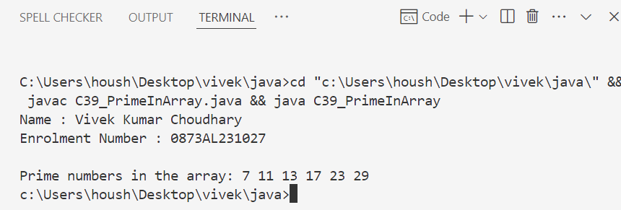
40. Can we inherit a Constructor?
Ans :
No, constructors cannot be inherited in Java.

Explanation in Bullet Points:
- A constructor is not inherited because it's not a member of the class.
- Constructors are special methods used to initialize objects of a class.
- When a subclass is created, it does not inherit the constructor from the superclass.
- However, a subclass can call the constructor of the superclass using the super() keyword.
- The subclass can also define its own constructors.

41. How will you implement method overloading in Java?
Ans :
Method Overloading in Java means defining multiple methods with the same name in the same class, but with different parameters.

Ways to Implement Method Overloading:
- By changing the number of parameters
- By changing the type of parameters
- By changing the order of parameters (of different types)

42. What is Runtime Polymorphism?
Ans : Runtime Polymorphism (also known as Dynamic Method Dispatch) is a form of polymorphism where the method call is resolved at runtime, not at compile time.

Key Points (Bullet Format):
- Occurs when a subclass overrides a method of its superclass.
- The method to be executed is determined at runtime based on the object type, not the reference type.
- Achieved using method overriding and inheritance.
- Uses dynamic binding (also called late binding).
- Enables Java to support one interface, multiple implementations (OOP principle).

43. How does Garbage Collection work in Java?
Ans :

Garbage Collection (GC) Overview:
- Java automatically manages memory using Garbage Collection.
- GC identifies and removes objects that are no longer reachable or needed by the program.
- This helps prevent memory leaks and optimizes memory usage.

How Garbage Collection Works:
- Object Creation:
  - When you create objects using new, memory is allocated on the heap.
- Reachability:
  - Objects are considered reachable if they can be accessed through any chain of references from root objects (like local variables, static fields).
- Marking:
  - GC marks all reachable objects.
- Sweeping:
  - Objects not marked (unreachable) are considered garbage.
  - These objects' memory is freed and returned to the heap for future allocation.
- Compaction (optional):
  - Some GC algorithms compact memory by moving objects to reduce fragmentation.

Types of Garbage Collectors in Java:
- Serial Garbage Collector: Single-threaded, suitable for small apps.
- Parallel Garbage Collector: Uses multiple threads for faster GC.
- CMS (Concurrent Mark Sweep): Low pause time, good for interactive apps.
- G1 Garbage Collector: Divides heap into regions, balances throughput and pause times.

44. Write a Java program to create an ArrayList, add some colors (as strings), and print the collection.
Ans :
import java.util.ArrayList;

public class C44_ColorList {
public static void main(String[] args) {
Name.info(); // Print name and enrollment number

// Create an ArrayList of Strings
ArrayList<String> colors = new ArrayList<>();

// Add some colors to the ArrayList
colors.add("Red");
colors.add("Green");
colors.add("Blue");
colors.add("Yellow");
colors.add("Orange");

// Print the ArrayList
System.out.println("Colors in the list: " + colors);
}
}

#output

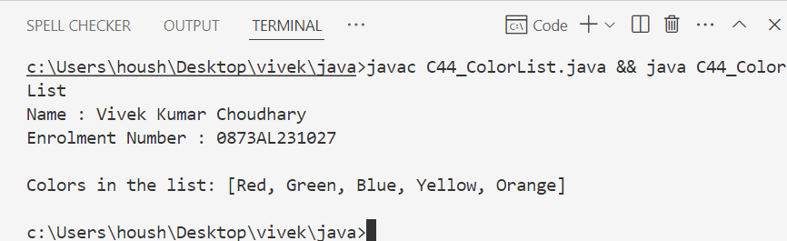

45. Write a Java program to iterate through all elements in an ArrayList.
Ans :
import java.util.ArrayList;
import java.util.Iterator;

public class C45_IterateArrayList {
public static void main(String[] args) {
Name.info(); // Print name and enrollment number

// Create an ArrayList of Strings
ArrayList<String> colors = new ArrayList<>();

// Add some colors
colors.add("Red");
colors.add("Green");
colors.add("Blue");
colors.add("Yellow");
colors.add("Orange");

System.out.println("Iterating using for-each loop:");
for (String color : colors) {
System.out.println(color);
}

System.out.println("\nIterating using Iterator:");
Iterator<String> it = colors.iterator();
while (it.hasNext()) {
System.out.println(it.next());
}

System.out.println("\nIterating using for loop with index:");
for (int i = 0; i < colors.size(); i++) {
System.out.println(colors.get(i));
}
}
}

#output

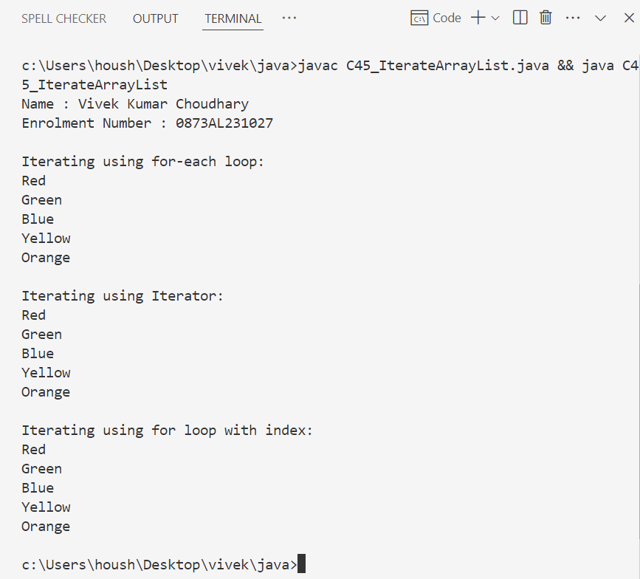

46. Write a Java program to insert an element into the ArrayList at the first position.
Ans :
import java.util.ArrayList;

public class C46_InsertAtFirstPosition {
public static void main(String[] args) {
Name.info(); // Print name and enrollment number

ArrayList<String> colors = new ArrayList<>();

// Add some initial colors
colors.add("Green");
colors.add("Blue");
colors.add("Yellow");

System.out.println("Before insertion: " + colors);

// Insert an element at the first position (index 0)
colors.add(0, "Red");

System.out.println("After insertion at first position: " + colors);
}
}

#output

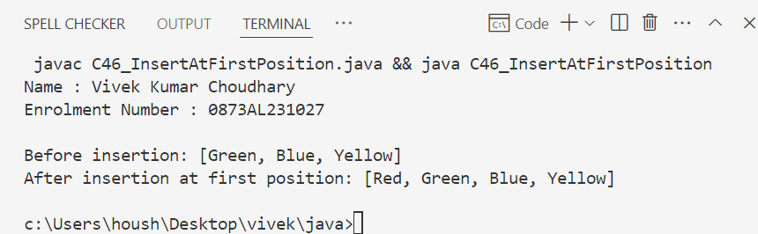

47. Write a Java program to retrieve an element at a specified index from a given ArrayList.
Ans :
import java.util.ArrayList;
import java.util.Scanner;

public class C47_RetrieveElement {
public static void main(String[] args) {
Name.info(); // Print name and enrollment number

ArrayList<String> colors = new ArrayList<>();
colors.add("Red");
colors.add("Green");
colors.add("Blue");
colors.add("Yellow");
colors.add("Orange");

Scanner sc = new Scanner(System.in);
System.out.print("Enter the index to retrieve element: ");
int index = sc.nextInt();

if (index >= 0 && index < colors.size()) {
String element = colors.get(index);
System.out.println("Element at index " + index + " is: " + element);
} else {
System.out.println("Invalid index! Please enter index between 0 and " + (colors.size() - 1));
}

sc.close();
}
}
#output

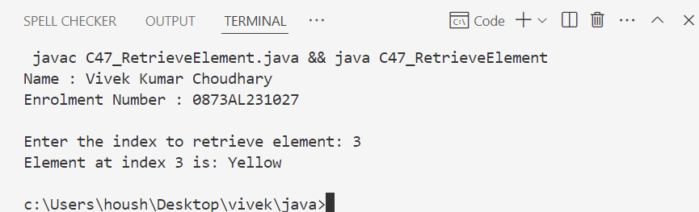

48. Write a Java program to update an ArrayList element by a given element.
Ans :
import java.util.ArrayList;
import java.util.Scanner;
public class C48_UpdateArrayListElement {
public static void main(String[] args) {
Name.info(); // Print name and enrollment number
ArrayList<String> colors = new ArrayList<>();
colors.add("Red");
colors.add("Green");
colors.add("Blue");
colors.add("Yellow");
colors.add("Orange");
Scanner sc = new Scanner(System.in);
System.out.println("Original list: " + colors);
System.out.print("Enter the index of element to update: ");
int index = sc.nextInt();
sc.nextLine(); // consume newline
if (index >= 0 && index < colors.size()) {
System.out.print("Enter new color to update: ");
String newColor = sc.nextLine();

colors.set(index, newColor); // Update element

System.out.println("Updated list: " + colors);
} else {
System.out.println("Invalid index! Please enter index between 0 and " + (colors.size() - 1));
}
sc.close();
}
}
#output
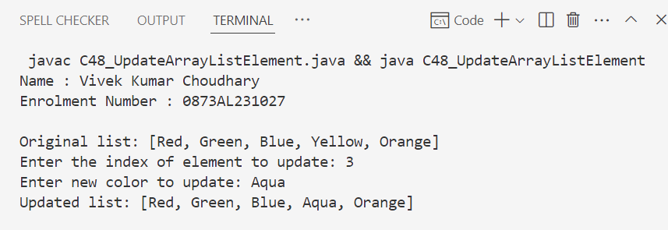

49. Write a Java program to remove the third element from an ArrayList.
Ans :
import java.util.ArrayList;

public class C49_RemoveThirdElement {
public static void main(String[] args) {
Name.info(); // Print name and enrollment number

ArrayList<String> colors = new ArrayList<>();
colors.add("Red");
colors.add("Green");
colors.add("Blue");
colors.add("Yellow");
colors.add("Orange");

System.out.println("Original list: " + colors);

if (colors.size() >= 3) {
colors.remove(2); // Remove element at index 2 (third element)
System.out.println("After removing third element: " + colors);
} else {
System.out.println("List has less than 3 elements, cannot remove third element.");
}
}
}

#output

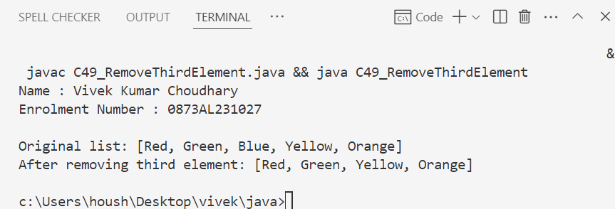

50. Write a Java program to search for an element in an ArrayList.
Ans :
import java.util.ArrayList;
import java.util.Scanner;

public class C50_SearchElementInArrayList {
public static void main(String[] args) {
Name.info(); // Print name and enrollment number

ArrayList<String> colors = new ArrayList<>();
colors.add("Red");
colors.add("Green");
colors.add("Blue");
colors.add("Yellow");
colors.add("Orange");

Scanner sc = new Scanner(System.in);
System.out.print("Enter color to search: ");
String searchColor = sc.nextLine();

if (colors.contains(searchColor)) {
System.out.println(searchColor + " is found in the list.");
} else {
System.out.println(searchColor + " is NOT found in the list.");
}

sc.close();
}
}

#output

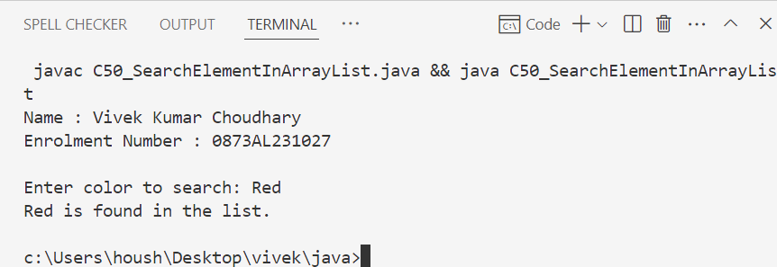
51. Write a Java program to sort a given ArrayList.
Ans :
import java.util.ArrayList;
import java.util.Collections;

public class C51_SortArrayList {
public static void main(String[] args) {
Name.info(); // Print name and enrollment number

ArrayList<String> colors = new ArrayList<>();
colors.add("Red");
colors.add("Green");
colors.add("Blue");
colors.add("Yellow");
colors.add("Orange");

System.out.println("Original list: " + colors);

// Sorting the ArrayList
Collections.sort(colors);

System.out.println("Sorted list: " + colors);
}
}

#output

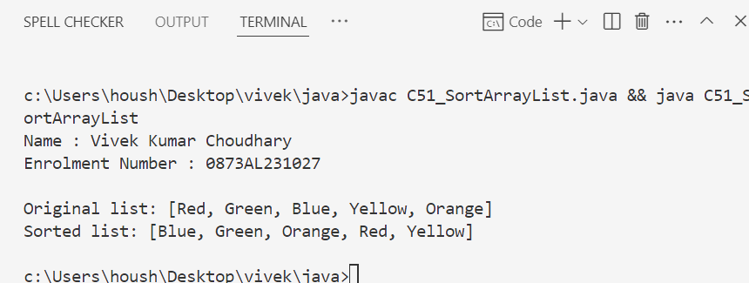

52. Write a Java program to copy one array list into another.
Ans :
import java.util.ArrayList;
import java.util.Collections;

public class C52_CopyArrayList {
public static void main(String[] args) {
Name.info(); // Print name and enrollment number

// Source ArrayList
ArrayList<String> sourceList = new ArrayList<>();
sourceList.add("Red");
sourceList.add("Green");
sourceList.add("Blue");
// Destination ArrayList (should be at least the same size as urceList)
ArrayList<String> destinationList = new ArrayList<>();
destinationList.add("White");
destinationList.add("Black");
destinationList.add("Gray");

System.out.println("Source List: " + sourceList);
System.out.println("Destination List (before copy): " + destinationList);

// Copy sourceList into destinationList
Collections.copy(destinationList, sourceList);

System.out.println("Destination List (after copy): " + destinationList);
}
}

#output

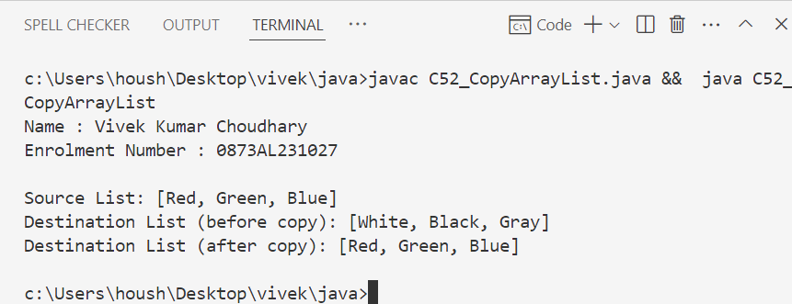
53. Write a Java program to shuffle elements in an array list.
Ans :
import java.util.ArrayList;
import java.util.Collections;

public class C53_ShuffleArrayList {
public static void main(String[] args) {
Name.info(); // Print name and enrollment number

ArrayList<String> colors = new ArrayList<>();
colors.add("Red");
colors.add("Green");
colors.add("Blue");
colors.add("Yellow");
colors.add("Orange");

System.out.println("Original List: " + colors);

// Shuffling the list
Collections.shuffle(colors);

System.out.println("Shuffled List: " + colors);
}
}

#output

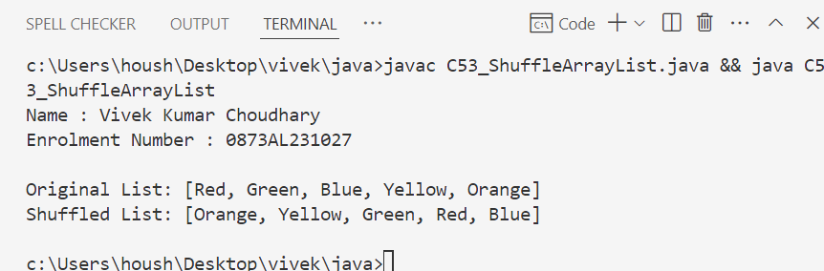

54. Write a Java program to reverse elements in an array list.
Ans :
import java.util.ArrayList;
import java.util.Collections;

public class C54_ReverseArrayList {
public static void main(String[] args) {
Name.info(); // Print name and enrollment number

ArrayList<String> colors = new ArrayList<>();
colors.add("Red");
colors.add("Green");
colors.add("Blue");
colors.add("Yellow");
colors.add("Orange");

System.out.println("Original List: " + colors);

// Reversing the list
Collections.reverse(colors);

System.out.println("Reversed List: " + colors);
}
}

#output

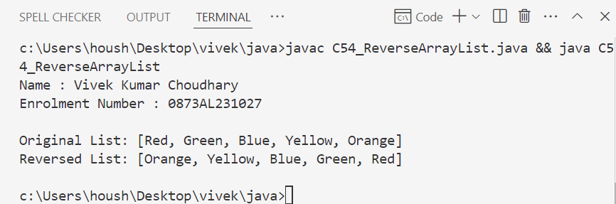

55. Write a Java program to extract a portion of an array list.
Ans :
import java.util.ArrayList;
import java.util.List;

public class C55_ExtractArrayListPortion {
public static void main(String[] args) {
Name.info(); // Print name and enrollment number

ArrayList<String> colors = new ArrayList<>();
colors.add("Red");
colors.add("Green");
colors.add("Blue");
colors.add("Yellow");
colors.add("Orange");

System.out.println("Original List: " + colors);

// Extracting a portion (from index 1 to 4, exclusive of 4)
List<String> subList = colors.subList(1, 4);

System.out.println("Extracted Portion (index 1 to 3): " + subList);
}
}

#output

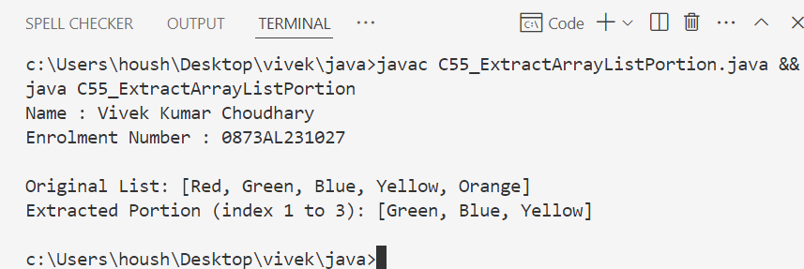

56. Write a Java program to compare two array lists.
Ans :
import java.util.ArrayList;

public class C56_CompareArrayLists {
public static void main(String[] args) {
Name.info(); // Print name and enrollment number

ArrayList<String> list1 = new ArrayList<>();
list1.add("Red");
list1.add("Green");
list1.add("Blue");

ArrayList<String> list2 = new ArrayList<>();
list2.add("Red");
list2.add("Green");
list2.add("Blue");

ArrayList<String> list3 = new ArrayList<>();
list3.add("Green");
list3.add("Red");
list3.add("Blue");

// Compare list1 and list2
boolean isEqual12 = list1.equals(list2);
System.out.println("list1 equals list2: " + isEqual12);

// Compare list1 and list3
boolean isEqual13 = list1.equals(list3);
System.out.println("list1 equals list3: " + isEqual13);
}
}

#output

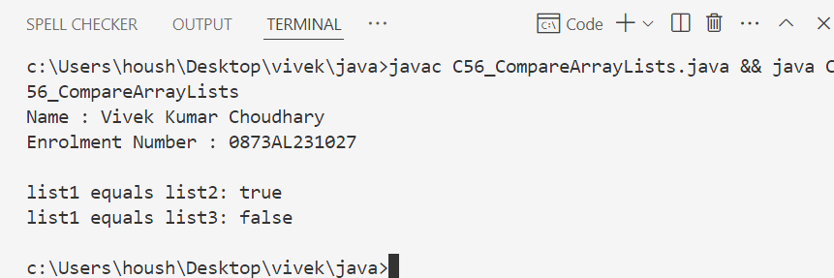
57. Write a Java program that swaps two elements in an array list.
Ans :
import java.util.ArrayList;
import java.util.Collections;

public class C57_SwapArrayListElements {
public static void main(String[] args) {
Name.info(); // Print name and enrollment number

ArrayList<String> colors = new ArrayList<>();
colors.add("Red");
colors.add("Green");
colors.add("Blue");
colors.add("Yellow");

System.out.println("Original List: " + colors);

// Swapping elements at index 1 and 3
Collections.swap(colors, 1, 3);

System.out.println("List after swapping index 1 and 3: " + colors);
}
}

#output

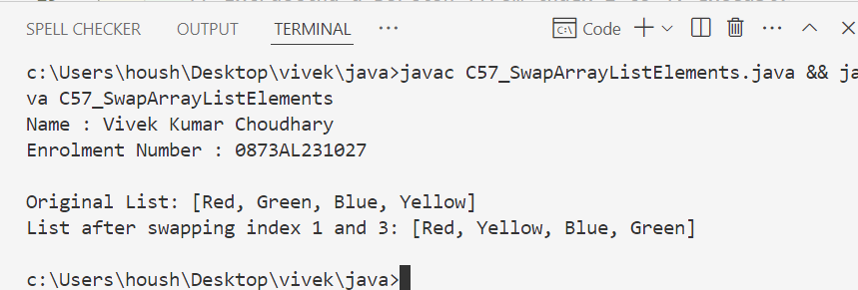

58. Write a Java program to join two array lists.
Ans :
import java.util.ArrayList;

public class C58_JoinArrayLists {
public static void main(String[] args) {
Name.info(); // Print name and enrollment number

// First ArrayList
ArrayList<String> list1 = new ArrayList<>();
list1.add("Red");
list1.add("Green");
list1.add("Blue");

// Second ArrayList
ArrayList<String> list2 = new ArrayList<>();
list2.add("Yellow");
list2.add("Orange");
list2.add("Purple");

System.out.println("List 1: " + list1);
System.out.println("List 2: " + list2);

// Joining list2 into list1
list1.addAll(list2);

System.out.println("Joined List: " + list1);
}
}

#output

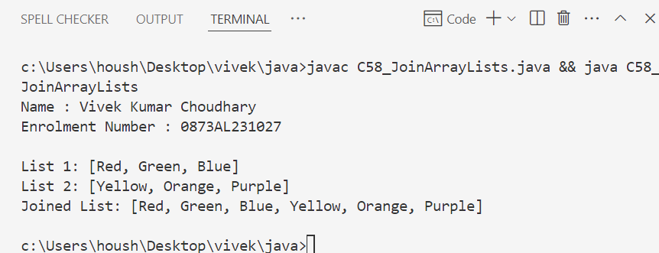

59. Write a Java program to clone an array list to another array list.
Ans :
import java.util.ArrayList;

public class C59_CloneArrayList {
public static void main(String[] args) {
Name.info(); // Print name and enrollment number

ArrayList<String> originalList = new ArrayList<>();
originalList.add("Red");
originalList.add("Green");
originalList.add("Blue");

// Cloning the ArrayList
ArrayList<String> clonedList = (ArrayList<String>) originalList.clone();

System.out.println("Original List: " + originalList);
System.out.println("Cloned List: " + clonedList);
}
}

#output

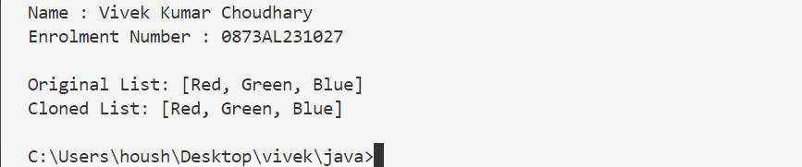

60. Write a Java program to empty an array list.
Ans :
import java.util.ArrayList;

public class C60_EmptyArrayList {
public static void main(String[] args) {
Name.info(); // Print name and enrollment number

ArrayList<String> colors = new ArrayList<>();
colors.add("Red");
colors.add("Green");
colors.add("Blue");

System.out.println("Before emptying: " + colors);

// Emptying the list
colors.clear();

System.out.println("After emptying: " + colors);
}
}

#output

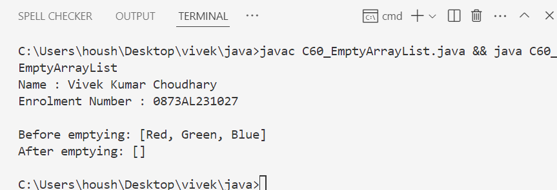

61. Write a Java program to test whether an array list is empty or not.
Ans :
import java.util.ArrayList;

public class C61_CheckIfArrayListEmpty {
public static void main(String[] args) {
Name.info(); // Print name and enrollment number

ArrayList<String> colors = new ArrayList<>();

// Check if list is empty
if (colors.isEmpty()) {
System.out.println("The ArrayList is empty.");
} else {
System.out.println("The ArrayList is not empty.");
}
}
}

#output

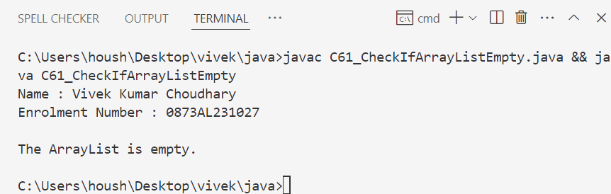

62. Write a Java program for trimming the capacity of an array list.
Ans :
import java.util.ArrayList;

public class C62_TrimArrayList {
public static void main(String[] args) {
Name.info(); // Print name and enrollment number

ArrayList<String> colors = new ArrayList<>(20); // initial capacity 20
colors.add("Red");
colors.add("Green");
colors.add("Blue");

System.out.println("Size before trimming: " + colors.size());

// Trimming capacity to the current size
colors.trimToSize();

System.out.println("Size after trimming: " + colors.size());
}
}

#output

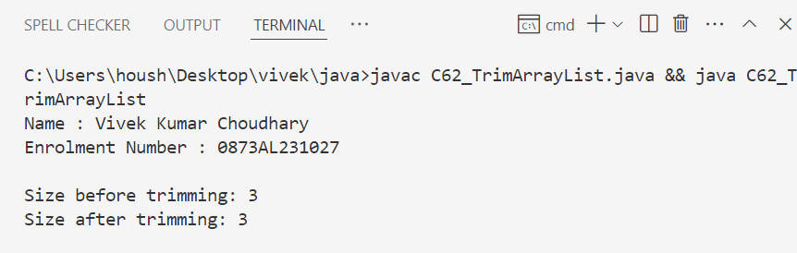

63. Write a Java program to increase an array list size.
Ans :
import java.util.ArrayList;

public class C63_EnsureCapacityArrayList {
public static void main(String[] args) {
Name.info(); // Print name and enrollment number

ArrayList<String> colors = new ArrayList<>();
colors.add("Red");
colors.add("Green");

// Increasing the capacity to store at least 10 elements
colors.ensureCapacity(10);

System.out.println("ArrayList capacity increased using ensureCapacity().");
System.out.println("Current size: " + colors.size());
}
}

#output

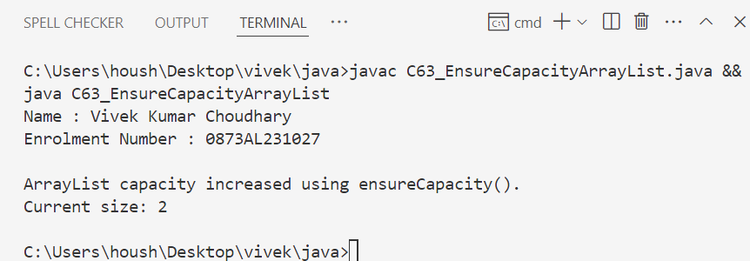

64. Write a Java program to replace the second element of an ArrayList with the specified element.
Ans :
import java.util.ArrayList;

public class C64_ReplaceSecondElement {
public static void main(String[] args) {
Name.info(); // Print name and enrollment number

ArrayList<String> colors = new ArrayList<>();
colors.add("Red");
colors.add("Green");
colors.add("Blue");

System.out.println("Original List: " + colors);

// Replacing second element (index 1)
colors.set(1, "Yellow");

System.out.println("List after replacement: " + colors);
}
}

#output

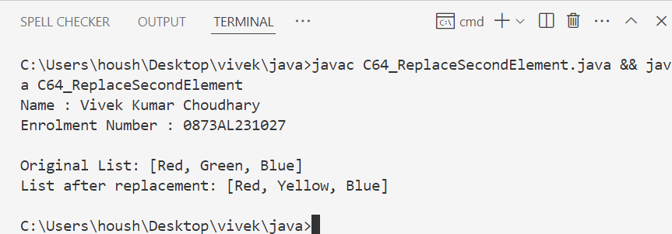

65. Write a Java program to print all the elements of an ArrayList using the elements' position.
Ans :
import java.util.ArrayList;

public class C65_PrintElementsByPosi66tion {
public static void main(String[] args) {
Name.info(); // Print name and enrollment number

ArrayList<String> colors = new ArrayList<>();
colors.add("Red");
colors.add("Green");
colors.add("Blue");
colors.add("Yellow");

System.out.println("Elements in the ArrayList:");

// Using for loop with index to print elements by position
for (int i = 0; i < colors.size(); i++) {
System.out.println("Element at position " + i + ": " + colors.get(i));
}
}
}

#output

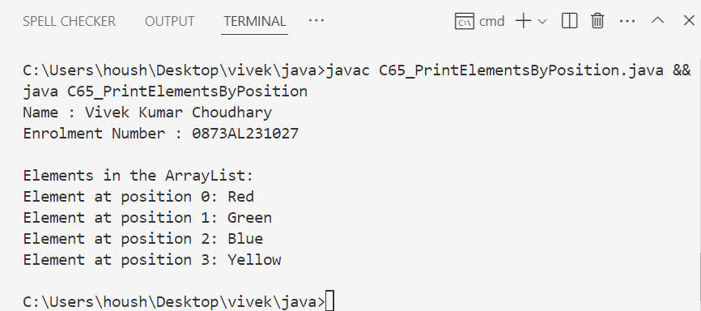

66. Write a Java program to append a specified element to the end of a linked list.
Ans :
import java.util.LinkedList;

public class C66_AppendToLinkedList {
public static void main(String[] args) {
Name.info(); // method to print name and enrollment number

LinkedList<String> colors = new LinkedList<>();
colors.add("Red");
colors.add("Green");
colors.add("Blue");

System.out.println("Original LinkedList: " + colors);

// Append element at end
colors.addLast("Yellow");

System.out.println("After appending: " + colors);
}
}

#output

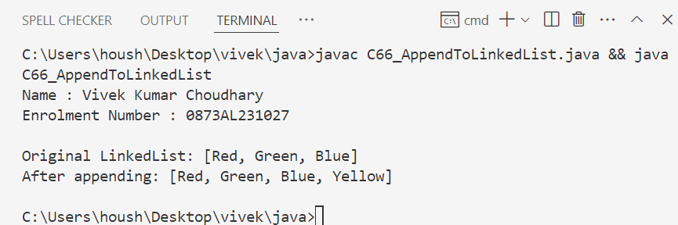

67. Write a Java program to iterate through all elements in a linked list.
Ans :
import java.util.LinkedList;

public class C67_IterateLinkedList {
public static void main(String[] args) {
Name.info(); // method to print name and enrollment number

LinkedList<String> names = new LinkedList<>();
names.add("Alice");
names.add("Bob");
names.add("Charlie");

System.out.println("Iterating through LinkedList:");

for (String name : names) {
System.out.println(name);
}
}
}

#output

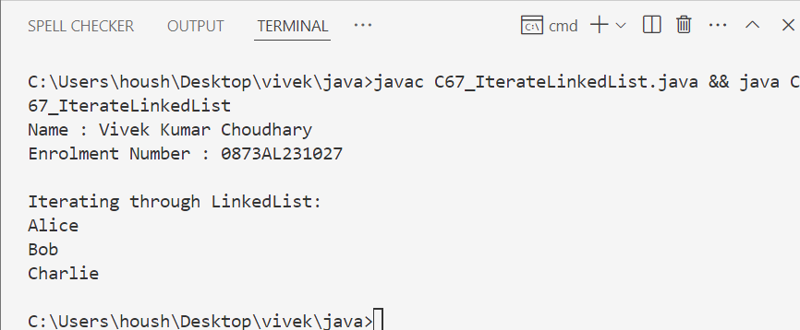

68. Write a Java program to iterate through all elements starting from a specified position in a linked list.
Ans :
import java.util.LinkedList;

public class C68_IterateFromPosition {
public static void main(String[] args) {
Name.info(); // method to print name and enrollment number

LinkedList<String> fruits = new LinkedList<>();
fruits.add("Apple");
fruits.add("Banana");
fruits.add("Cherry");
fruits.add("Date");

int startIndex = 2; // starting from index 2

System.out.println("Iterating from index " + startIndex + ":");

for (int i = startIndex; i < fruits.size(); i++) {
System.out.println("Element at index " + i + ": " + fruits.get(i));
}
}
}

#output

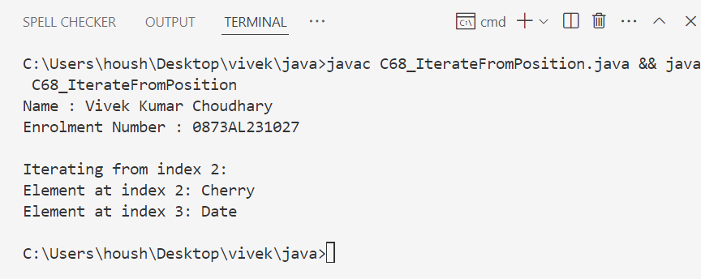

69. Write a Java program to iterate a linked list in reverse order.
Ans :
import java.util.LinkedList;
import java.util.Iterator;

public class C69_ReverseIterateLinkedList {
public static void main(String[] args) {
Name.info(); // method to print name and enrollment number

LinkedList<String> cities = new LinkedList<>();
cities.add("Delhi");
cities.add("Mumbai");
cities.add("Chennai");
cities.add("Kolkata");

System.out.println("Iterating in reverse order:");

Iterator<String> itr = cities.descendingIterator();
while (itr.hasNext()) {
System.out.println(itr.next());
}
}
}

#output

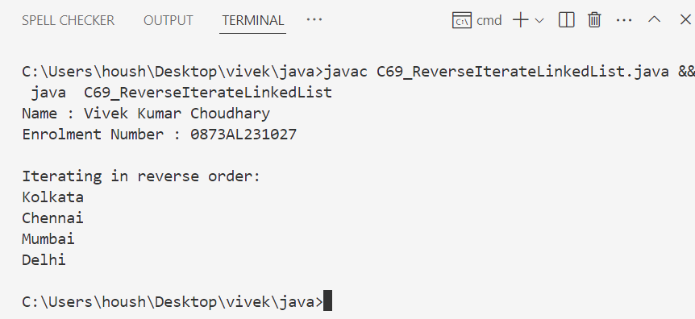

70. Write a Java program to insert a specified element at a given position in a linked list.
Ans :
import java.util.LinkedList;

public class C70_InsertAtPosition {
public static void main(String[] args) {
Name.info(); // method to print name and enrollment number

LinkedList<String> animals = new LinkedList<>();
animals.add("Dog");
animals.add("Cat");
animals.add("Elephant");

System.out.println("Original LinkedList: " + animals);

// Insert "Lion" at index 1
animals.add(1, "Lion");

System.out.println("After inserting at position 1: " + animals);
}
}

#output

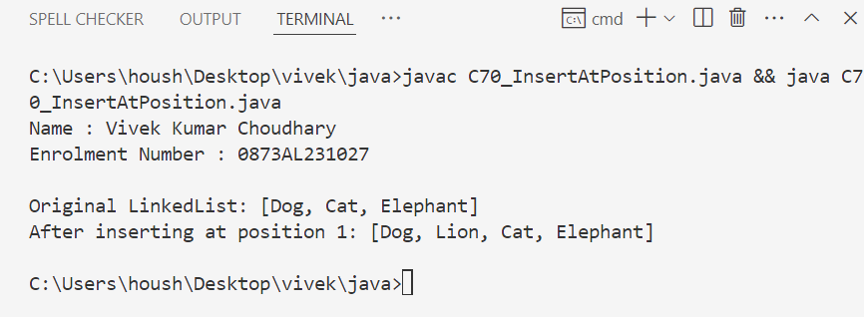

71. Write a Java program to insert elements at the first and last positions of a linked list.
Ans :
import java.util.LinkedList;

public class C71_InsertAtFirstLast {
public static void main(String[] args) {
Name.info(); // method to print name and enrollment number

LinkedList<String> cars = new LinkedList<>();
cars.add("BMW");
cars.add("Audi");

System.out.println("Original LinkedList: " + cars);

// Insert at first and last positions
cars.addFirst("Tesla");
cars.addLast("Mercedes");

System.out.println("After inserting at first and last: " + cars);
}
}

#output

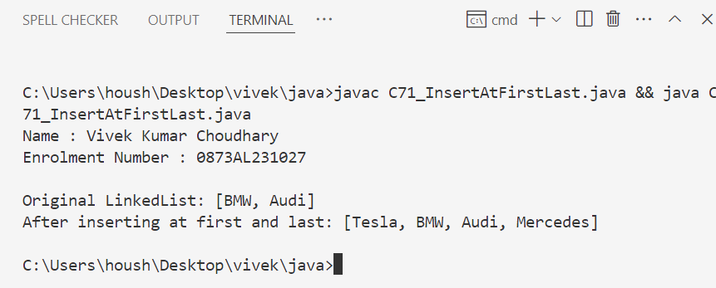

72. Write a Java program to add all elements from one TreeSet to another TreeSet.
Ans :
import java.util.TreeSet;

public class C72_AddTreeSets {
public static void main(String[] args) {
Name.info(); // method to print name and enrollment number

TreeSet<String> set1 = new TreeSet<>();
set1.add("Red");
set1.add("Green");
set1.add("Blue");

TreeSet<String> set2 = new TreeSet<>();
set2.addAll(set1);

System.out.println("First TreeSet: " + set1);
System.out.println("Second TreeSet after adding: " + set2);
}
}

#output

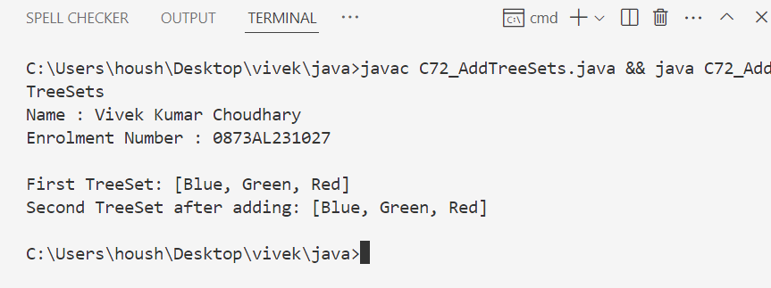

73. Write a Java program to display the elements of a TreeSet in reverse order.
Ans :
import java.util.TreeSet;
import java.util.Iterator;

public class C73_ReverseTreeSet {
public static void main(String[] args) {
Name.info(); // method to print name and enrollment number

TreeSet<Integer> numbers = new TreeSet<>();
numbers.add(10);
numbers.add(5);
numbers.add(20);
numbers.add(15);

Iterator<Integer> reverseItr = numbers.descendingIterator();
System.out.println("TreeSet in reverse order:");
while (reverseItr.hasNext()) {
System.out.println(reverseItr.next());
}
}
}

#output

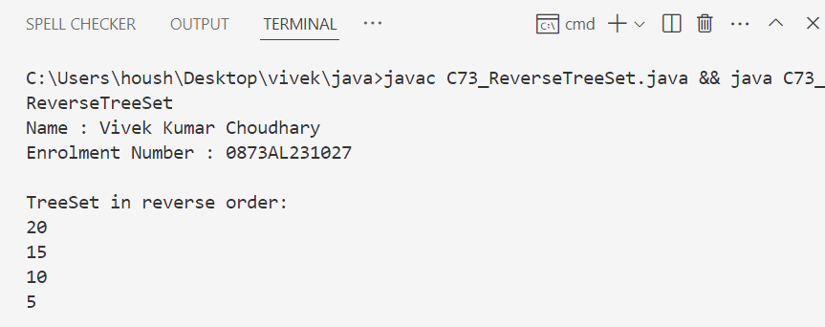

74. Write a Java program to retrieve the first and last elements from a TreeSet.
Ans :
import java.util.TreeSet;

public class C74_FirstLastTreeSet {
public static void main(String[] args) {
Name.info(); // method to print name and enrollment number

TreeSet<String> names = new TreeSet<>();
names.add("Alice");
names.add("Bob");
names.add("Charlie");
names.add("David");

System.out.println("First Element: " + names.first());
System.out.println("Last Element: " + names.last());
}
}

#output

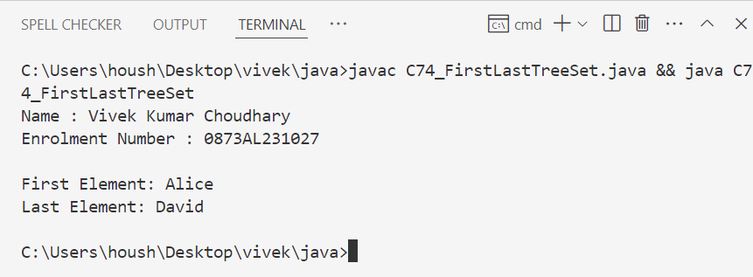

75. Write a Java program to clone a TreeSet into another TreeSet
Ans :
import java.util.TreeSet;

public class C75_CloneTreeSet {
public static void main(String[] args) {
Name.info(); // method to print name and enrollment number

TreeSet<String> original = new TreeSet<>();
original.add("One");
original.add("Two");
original.add("Three");

TreeSet<String> cloned = (TreeSet<String>) original.clone();

System.out.println("Original TreeSet: " + original);
System.out.println("Cloned TreeSet: " + cloned);
}
}

#output

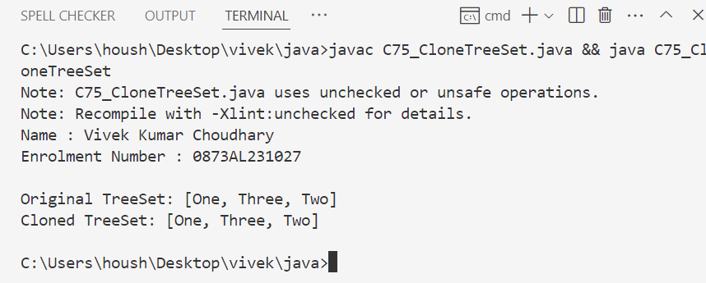

76. Write a Java program to count the number of elements in a TreeSet.
Ans :
import java.util.TreeSet;

public class C76_CountTreeSet {
public static void main(String[] args) {
Name.info(); // method to print name and enrollment number

TreeSet<Integer> numbers = new TreeSet<>();
numbers.add(10);
numbers.add(20);
numbers.add(30);
numbers.add(40);

System.out.println("Total number of elements: " + numbers.size());
}
}

#output

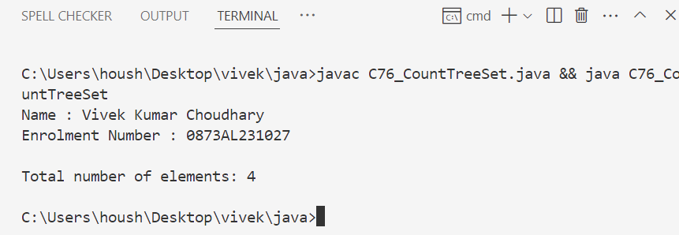

77. Write a Java program to compare two TreeSets.
Ans :
import java.util.TreeSet;

public class C77_CompareTreeSets {
public static void main(String[] args) {
Name.info(); // method to print name and enrollment number

TreeSet<String> set1 = new TreeSet<>();
set1.add("A");
set1.add("B");
set1.add("C");

TreeSet<String> set2 = new TreeSet<>();
set2.add("B");
set2.add("C");
set2.add("D");

for (String element : set1) {
if (set2.contains(element)) {
System.out.println(element + " is present in both sets.");
} else {
System.out.println(element + " is not present in both sets.");
}
}
}
}

#output

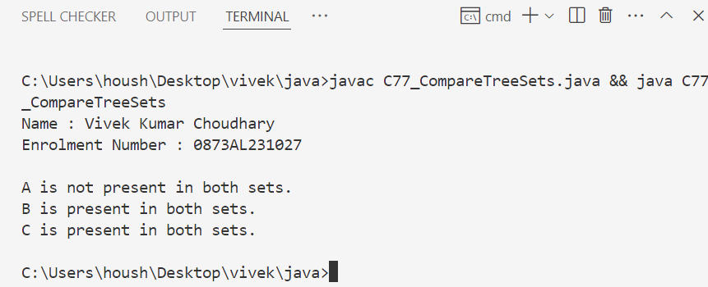

78. Write a Java program to clone one HashSet into another.
Ans :
import java.util.HashSet;

public class C78_CloneHashSet {
public static void main(String[] args) {
Name.info(); // method to print name and enrollment number

HashSet<String> original = new HashSet<>();
original.add("Apple");
original.add("Banana");
original.add("Cherry");

HashSet<String> clone = (HashSet<String>) original.clone();

System.out.println("Original HashSet: " + original);
System.out.println("Cloned HashSet: " + clone);
}
}

#output

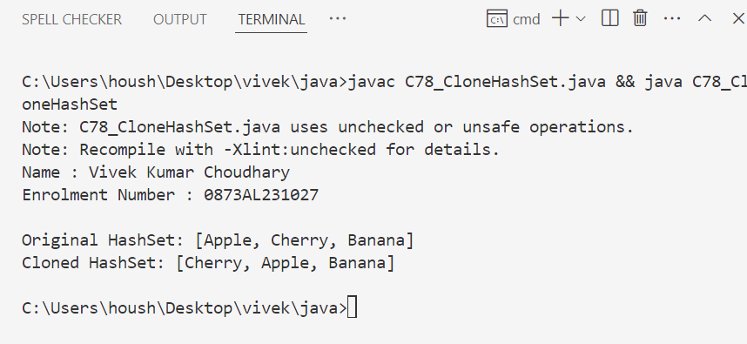

79. Write a Java program to convert a HashSet into an array.
Ans :
import java.util.HashSet;

public class C79_HashSetToArray {
public static void main(String[] args) {
Name.info();

HashSet<String> set = new HashSet<>();
set.add("Red");
set.add("Green");
set.add("Blue");

String[] array = new String[set.size()];
set.toArray(array);

System.out.println("Array elements:");
for (String color : array) {
System.out.println(color);
}
}
}

#output

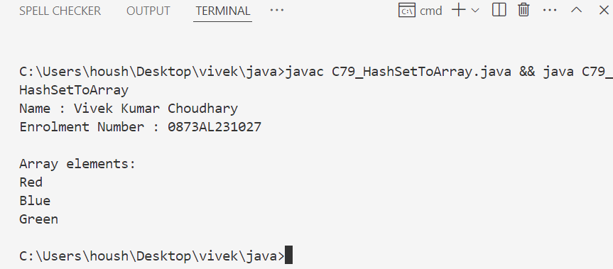

80. Write a Java program to convert a HashSet into a TreeSet.
Ans :
import java.util.HashSet;
import java.util.TreeSet;

public class C80_HashSetToTreeSet {
public static void main(String[] args) {
Name.info();

HashSet<String> hashSet = new HashSet<>();
hashSet.add("Orange");
hashSet.add("Mango");
hashSet.add("Apple");

TreeSet<String> treeSet = new TreeSet<>(hashSet);
System.out.println("TreeSet elements: " + treeSet);
}
}

#output

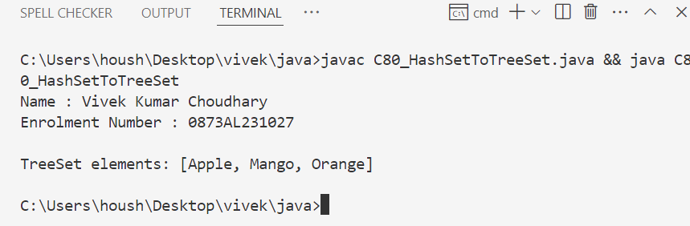

81. Write a Java program to find numbers less than 7 in a TreeSet.
Ans :
import java.util.TreeSet;

public class C81_LessThanSeven {
public static void main(String[] args) {
Name.info();

TreeSet<Integer> numbers = new TreeSet<>();
numbers.add(2);
numbers.add(5);
numbers.add(8);
numbers.add(1);
numbers.add(10);

System.out.println("Numbers less than 7:");
for (Integer num : numbers.headSet(7)) {
System.out.println(num);
}
}
}

#output

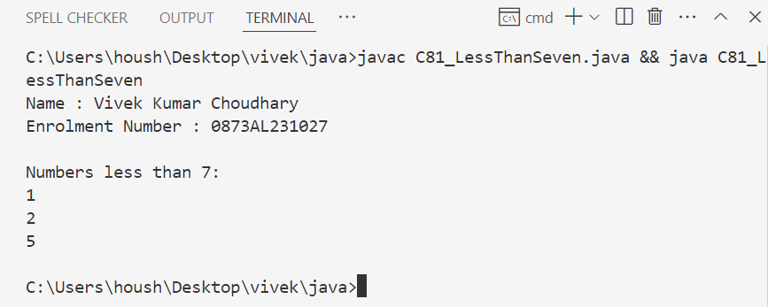

82. Write a Java program to compare two HashSets.
Ans :
import java.util.HashSet;

public class C82_CompareHashSets {
public static void main(String[] args) {
Name.info();

HashSet<String> set1 = new HashSet<>();
set1.add("Java");
set1.add("Python");
set1.add("C++");

HashSet<String> set2 = new HashSet<>();
set2.add("Python");
set2.add("C++");
set2.add("Java");

if (set1.equals(set2)) {
System.out.println("HashSets are equal.");
} else {
System.out.println("HashSets are not equal.");
}
}
}

#output

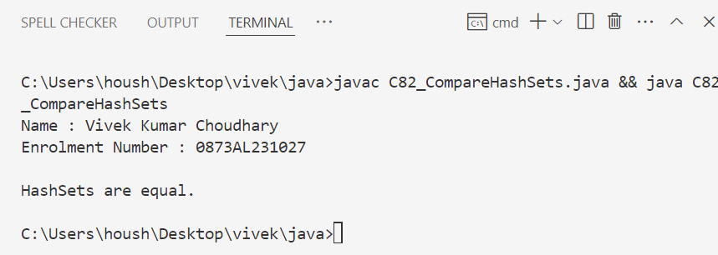

83. Write a Java program to retain common elements from two sets.
Ans :
import java.util.HashSet;

public class C83_CommonElements {
public static void main(String[] args) {
Name.info();

HashSet<String> set1 = new HashSet<>();
set1.add("A");
set1.add("B");
set1.add("C");

HashSet<String> set2 = new HashSet<>();
set2.add("B");
set2.add("C");
set2.add("D");

set1.retainAll(set2);
System.out.println("Common elements: " + set1);
}
}

#output

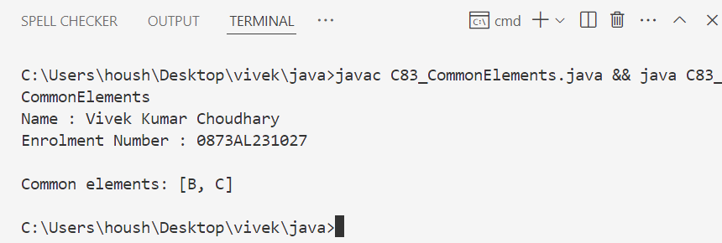

84. Write a Java program to remove all elements from a HashSet.
Ans :
import java.util.HashSet;

public class C84_ClearHashSet {
public static void main(String[] args) {
Name.info();

HashSet<String> colors = new HashSet<>();
colors.add("White");
colors.add("Black");
colors.add("Grey");

System.out.println("Before clearing: " + colors);
colors.clear();
System.out.println("After clearing: " + colors);
}
}

#output

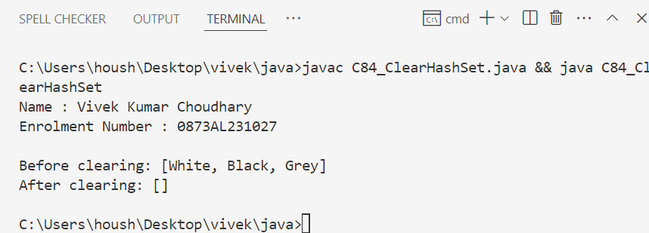

85. Write a Java program to copy all mappings from one map to another.
Ans :
import java.util.HashMap;
import java.util.Map;

public class C85_CopyMap {
public static void main(String[] args) {
Name.info(); // Method to print name and enrollment number

Map<Integer, String> map1 = new HashMap<>();
map1.put(1, "Apple");
map1.put(2, "Banana");
map1.put(3, "Cherry");

Map<Integer, String> map2 = new HashMap<>();
map2.putAll(map1); // Copy all mappings

System.out.println("Original Map: " + map1);
System.out.println("Copied Map: " + map2);
}
}

#output

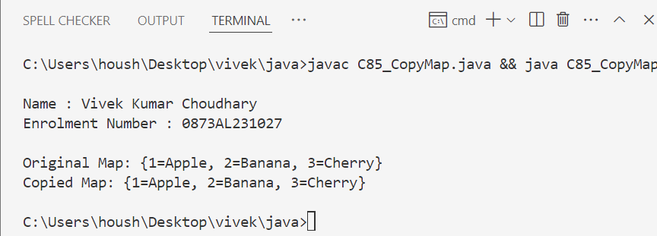

86. Write a Java program to remove all key-value pairs from a map.
Ans :
import java.util.HashMap;
import java.util.Map;

public class C86_ClearMap {
public static void main(String[] args) {
Name.info();

Map<String, Integer> map = new HashMap<>();
map.put("A", 100);
map.put("B", 200);
map.put("C", 300);

System.out.println("Before clearing: " + map);
map.clear();
System.out.println("After clearing: " + map);
}
}

#output

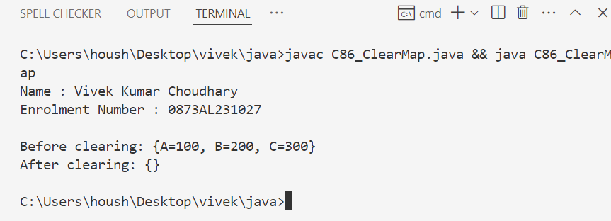

87. Write a Java program to check if a map is empty or contains key-value mappings.
Ans :
import java.util.HashMap;
import java.util.Map;

public class C87_CheckMapEmpty {
public static void main(String[] args) {
Name.info();

Map<String, String> map = new HashMap<>();

if (map.isEmpty()) {
System.out.println("Map is empty.");
} else {
System.out.println("Map contains: " + map);
}

map.put("Key1", "Value1");

if (!map.isEmpty()) {
System.out.println("Map now contains: " + map);
}
}
}

#output

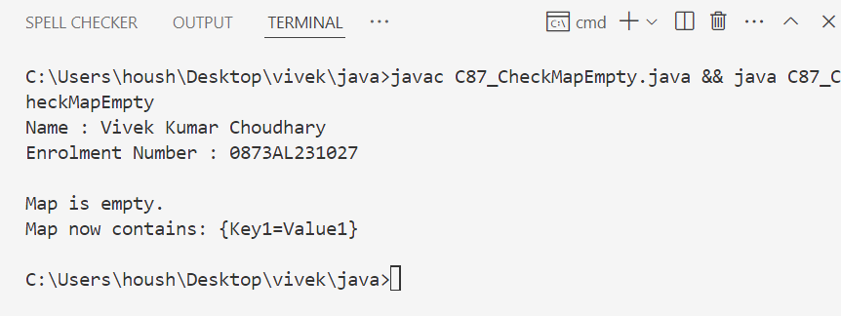

88. Write a Java program to create a shallow copy of a HashMap instance.
Ans :
import java.util.HashMap;

public class C88_ShallowCopyMap {
public static void main(String[] args) {
Name.info();

HashMap<Integer, String> original = new HashMap<>();
original.put(1, "Java");
original.put(2, "Python");

HashMap<Integer, String> shallowCopy = (HashMap<Integer, String>) original.clone();

System.out.println("Original Map: " + original);
System.out.println("Shallow Copy: " + shallowCopy);
}
}

#output

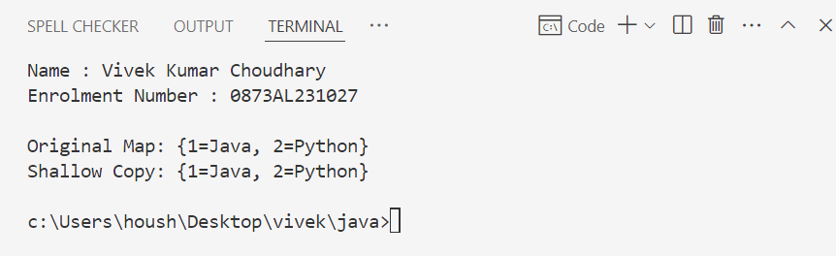

89. Write a Java program to test whether a specified key exists in the map.
Ans :
import java.util.HashMap;

public class C89_KeyExistsInMap {
public static void main(String[] args) {
Name.info();

HashMap<String, Integer> map = new HashMap<>();
map.put("Math", 90);
map.put("Science", 85);
map.put("English", 95);

String keyToCheck = "Science";

if (map.containsKey(keyToCheck)) {
System.out.println("Key \"" + keyToCheck + "\" exists with value: " + map.get(keyToCheck));
} else {
System.out.println("Key \"" + keyToCheck + "\" does not exist.");
}
}
}

#output

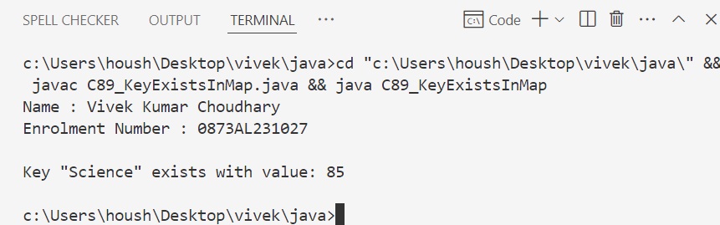

90. Create a table Item_dtls (Electronics)
Try to insert at least 10 records in the above table
Try to insert at least 2 records with null value
Ans :
CREATE TABLE Item_dtls (
Item_ID INT PRIMARY KEY,
Item_Name VARCHAR(100),
Manufacturer_ID INT,
Price DECIMAL(10,2),
Warranty_Years INT
);

-- Insert 10 records (2 with NULL values)
INSERT INTO Item_dtls VALUES (1, 'Smartphone', 1, 24999.99, 2);
INSERT INTO Item_dtls VALUES (2, 'Laptop', 2, 55999.00, 3);
INSERT INTO Item_dtls VALUES (3, 'Tablet', 3, 14999.50, 2);
INSERT INTO Item_dtls VALUES (4, 'Smartwatch', 4, 18999.99, 1);
INSERT INTO Item_dtls VALUES (5, 'Monitor', 5, 12999.00, 3);
INSERT INTO Item_dtls VALUES (6, 'Keyboard', 6, 1999.99, 1);
INSERT INTO Item_dtls VALUES (7, 'Mouse', 6, 899.50, 1);
INSERT INTO Item_dtls VALUES (8, 'Speakers', 7, 2499.75, 1);
INSERT INTO Item_dtls VALUES (9, NULL, 8, NULL, NULL); -- NULL values
INSERT INTO Item_dtls VALUES (10, 'Printer', NULL, 4999.99, 2); -- NULL manufacturer

#output

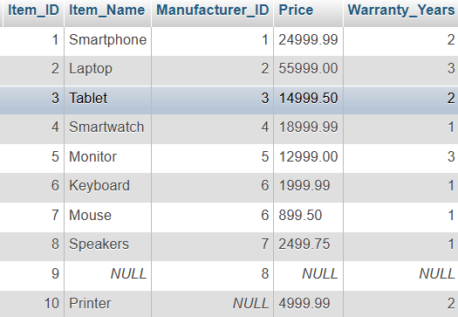

91. Create a table Sales_dtls
Try to insert at least 10 records in the above table
Try to insert at least 2 records with null value
Ans :
CREATE TABLE Sales_dtls (
Sale_ID INT PRIMARY KEY,
Item_ID INT,
Customer_Name VARCHAR(100),
Quantity INT,
Sale_Date DATE,
Total_Amount DECIMAL(10,2));
INSERT INTO Sales_dtls VALUES (1, 1, 'Ravi', 2, DATE '2025-06-01', 49999.98);
INSERT INTO Sales_dtls VALUES (2, 2, 'Anjali', 1, DATE '2025-06-02', 55999.00);
INSERT INTO Sales_dtls VALUES (3, 3, 'Nikhil', 3, DATE '2025-06-02', 44998.50);
INSERT INTO Sales_dtls VALUES (4, 4, 'Divya', 1, DATE '2025-06-03', 18999.99);
INSERT INTO Sales_dtls VALUES (5, 5, 'Suresh', 2, DATE '2025-06-03', 25998.00);
INSERT INTO Sales_dtls VALUES (6, 6, 'Kavita', 1, DATE '2025-06-04', 2999.75);
INSERT INTO Sales_dtls VALUES (7, 7, 'Rahul', 2, DATE '2025-06-04', 1799.00);
INSERT INTO Sales_dtls VALUES (8, 8, 'Sneha', 1, DATE '2025-06-05', 2499.00);
INSERT INTO Sales_dtls VALUES (9, NULL, 'Amit', 1, DATE '2025-06-06', NULL); -- NULL Item_ID, Total_Amount
INSERT INTO Sales_dtls VALUES (10, 10, NULL, NULL, NULL, NULL);
#output
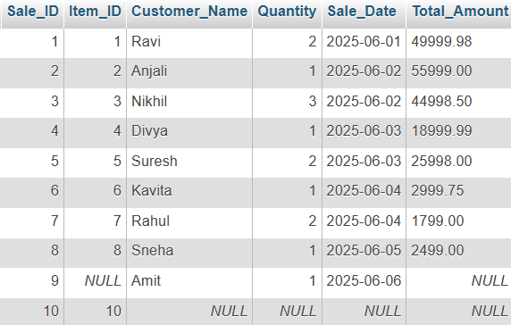

92. create a table manufacturers
Try to insert at least 10 records in the above table
Try to insert at least 2 records with null value
Ans :
CREATE TABLE manufacturers (
Manufacturer_ID INT PRIMARY KEY,
Manufacturer_Name VARCHAR(100),
Country VARCHAR(50),
Established_Year INT,
Email VARCHAR(100));
INSERT INTO manufacturers VALUES (1, 'Samsung', 'South Korea', 1969, 'info@samsung.com');
INSERT INTO manufacturers VALUES (2, 'Sony', 'Japan', 1946, 'info@sony.com');
INSERT INTO manufacturers VALUES (3, 'LG', 'South Korea', 1958, 'support@lg.com');
INSERT INTO manufacturers VALUES (4, 'HP', 'USA', 1939, 'support@hp.com');
INSERT INTO manufacturers VALUES (5, 'Apple', 'USA', 1976, 'apple@support.com');
INSERT INTO manufacturers VALUES (6, 'Dell', 'USA', 1984, 'dell@support.com');
INSERT INTO manufacturers VALUES (7, 'Lenovo', 'China', 1984, 'contact@lenovo.com');
INSERT INTO manufacturers VALUES (8, 'Xiaomi', 'China', 2010, 'xiaomi@support.com');
INSERT INTO manufacturers VALUES (9, 'Philips', NULL, 1891, NULL); -- NULL country and email
INSERT INTO manufacturers VALUES (10, NULL, 'Germany', NULL, NULL); -- NULL name, year, email
#output
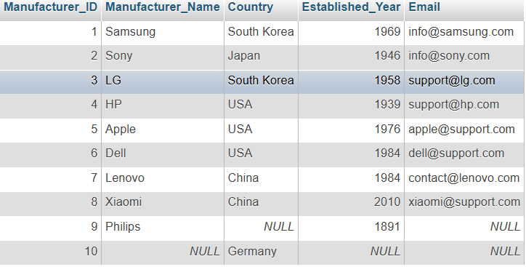
93. Consider the below tables with estimated columns and then practise below questions.
CUST DTLS
CUST Act DTLS
ACT_TYPES_INFO
PROD_DTLS
EMP
DEPT

Fetch all clerks information
Ans :
SELECT * FROM EMP WHERE Job_Title = 'Clerk';

#output

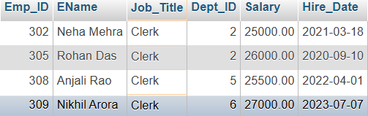

94. Display all departments information located at CHICAGO?
Ans :
SELECT * FROM DEPT WHERE Location = 'Chicago';

#output
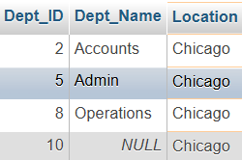

95. Display product details manufactured in the current year only?
Ans :
SELECT * FROM PROD_DTLS
WHERE YEAR(Manufacture_Date) = YEAR(CURDATE());

#output
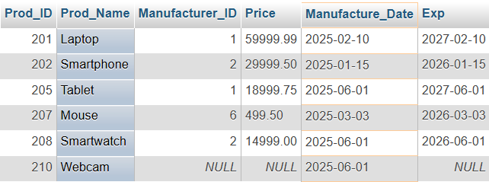

96. Get the details of customer accounts who opened the accounts before this year?
Ans :
SELECT * FROM CUST_ACT_DTLS
WHERE Open_Date IS NOT NULL
AND EXTRACT(YEAR FROM Open_Date) < YEAR(CURDATE());

#output

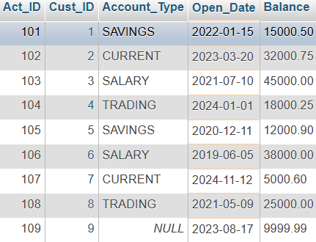
97. Get all SALARY account details?
Ans :
SELECT * FROM CUST_ACT_DTLS
WHERE Account_Type = 'SALARY';

#output

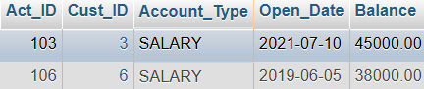

98. Display customer names and mobile numbers from the city 'Texas'?
select cname, mobile from cust_dtls where city='Texas';
Ans :
SELECT CName, Mobile FROM CUST_DTLS
WHERE City = 'Texas';

#output

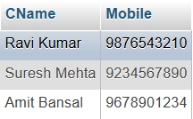

99. Get the information of Trading account?
Ans :
SELECT * FROM CUST_ACT_DTLS
WHERE Account_Type = 'TRADING';

#output

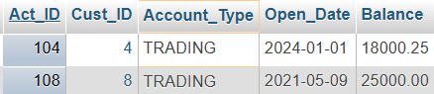

100. Display only Expired product details?
select * from prod_dtls where exp<sysdate;
Ans :
SELECT * FROM PROD_DTLS
WHERE Exp < CURDATE();

#output

